

CUSTOMER CHURN PREDICTION IN TELECOM INDUSTRY
(Machine Learning Based Customer Retention System)
An explainable churn-risk and retention application: ChurnIQ
A project report submitted in partial fulfilment of the requirements for the award of the degree of
BACHELOR OF TECHNOLOGY
in
COMPUTER SCIENCE AND ENGINEERING
Submitted by
ANANTULA SAI NIKHILA SRAVANI | 23K91A0512
AVULA ANUDEEP | 23K91A0518
B SANDEEP | 24K915A0503
DARAGANI VINOD KUMAR | 23K91A0558

Batch A14 (CSE-A)
Under the esteemed guidance of
B. SRIKANTH
Assistant Professor, Department of CSE
DEPARTMENT OF COMPUTER SCIENCE AND ENGINEERING
TKR COLLEGE OF ENGINEERING AND TECHNOLOGY (AUTONOMOUS)
Academic year [ACADEMIC YEAR]

CERTIFICATE
This is to certify that the project report entitled "Customer Churn Prediction in Telecom Industry (Machine Learning Based Customer Retention System)" is a bonafide record of the work carried out by ANANTULA SAI NIKHILA SRAVANI (23K91A0512), AVULA ANUDEEP (23K91A0518), B SANDEEP (24K915A0503), DARAGANI VINOD KUMAR (23K91A0558), in partial fulfilment of the requirements for the award of the degree of Bachelor of Technology in Computer Science and Engineering, during the academic year [ACADEMIC YEAR], under my supervision.

Project Guide | Head of the Department | Principal
B. SRIKANTH | [HOD NAME] | [PRINCIPAL NAME]
Assistant Professor, Department of CSE | Department of Computer Science and Engineering | TKR College of Engineering and Technology (Autonomous)

External Examiner: [NAME AND SIGNATURE]
Place: [PLACE]
Date: [DATE]

DECLARATION
We hereby declare that the project report entitled "Customer Churn Prediction in Telecom Industry (Machine Learning Based Customer Retention System)", submitted to the Department of Computer Science and Engineering, TKR College of Engineering and Technology (Autonomous), in partial fulfilment of the requirements for the award of the degree of Bachelor of Technology in Computer Science and Engineering, is a record of original work carried out by us under the guidance of B. SRIKANTH, Assistant Professor, Department of CSE. The results embodied in this report have not been submitted to any other university or institution for the award of any degree or diploma.

ANANTULA SAI NIKHILA SRAVANI 23K91A0512
AVULA ANUDEEP 23K91A0518
B SANDEEP 24K915A0503
DARAGANI VINOD KUMAR 23K91A0558

Place: [PLACE]
Date: [DATE]

ACKNOWLEDGEMENT
We express our sincere gratitude to our project guide, B. SRIKANTH, Assistant Professor, Department of CSE, for valuable guidance, encouragement and constructive suggestions throughout this project.
We thank [HOD NAME], Head of the Department of Computer Science and Engineering, for providing the facilities and support needed to complete this work, and [PRINCIPAL NAME], Principal, TKR College of Engineering and Technology (Autonomous), for the encouragement given to us.
We thank the project coordinators and all faculty and staff members of the department for their help, and our families and friends for their constant support.
We also acknowledge the authors of the base paper and of the related work we studied, the providers of the public Telco churn data set whose schema this project follows, and the developers of the open-source software used in this project (Python, scikit-learn, pandas, imbalanced-learn, FastAPI, Streamlit, React and Vite).

ANANTULA SAI NIKHILA SRAVANI
AVULA ANUDEEP
B SANDEEP
DARAGANI VINOD KUMAR

ABSTRACT
Customer churn, the loss of subscribers to a competitor, is costly for telecom operators because acquiring a new customer costs several times more than keeping an existing one, and because churn is usually noticed only after the customer has left. Customer records contain early signals such as tenure, contract type, monthly charges, internet service and payment method. This project builds a machine-learning customer-retention system around those signals. The data are loaded and profiled, cleaned, explored, and prepared with a pipeline that imputes, scales and one-hot encodes the fields. Logistic Regression, Decision Tree and Random Forest classifiers (and optionally Gradient Boosting) are trained with class weights or SMOTE to counter the minority churn class, compared on accuracy, precision, recall, F1-score and ROC-AUC, and the best model is saved.
Each customer receives a churn probability and a Low, Medium, High or Critical risk band with user-editable thresholds, the factors pushing the score up or down, a what-if analysis, and rule-based retention suggestions. A new customer file can be scored in batch and checked for drift. The system is delivered as the original Streamlit application and as a React web interface (ChurnIQ) over a FastAPI service.
Because no real operator data were available, the evaluation uses a synthetic 1,000-customer data set with the public Telco schema and 26.4% churn; the results describe the pipeline and not real customers. On the 200-row test split the best model by F1, Logistic Regression, reaches accuracy 0.630, recall 0.660, F1 0.486 and ROC-AUC 0.722. Cross-validation and repeated splits show spreads of 0.03 to 0.10 and that Logistic Regression and Random Forest cannot be separated reliably; without imbalance handling recall falls to 0.189 although accuracy looks good. The probabilities are not calibrated and are used as a ranking. SHAP was not installed, so explanations use coefficients and permutation importance. The base paper's unified explainer is not reproduced, and the metrics are not comparable with its real-data results. 44 unit tests and a 63-check end-to-end API test pass.
Keywords: customer churn prediction, machine learning, telecom analytics, customer retention, logistic regression, decision tree, random forest, exploratory data analysis, explainable AI.

TABLE OF CONTENTS
CERTIFICATE i
DECLARATION ii
ACKNOWLEDGEMENT iii
ABSTRACT iv
TABLE OF CONTENTS v
LIST OF FIGURES x
LIST OF TABLES xii
LIST OF ABBREVIATIONS xiv
CHAPTER 1: INTRODUCTION 1
1.1 Background 1
1.2 Motivation 1
1.3 Problem Statement 2
1.4 Objectives 2
1.5 Scope of the Project 3
1.6 Proposed System in Brief 3
1.7 Relation to the Base Paper 4
1.8 Data Used and a Caution 4
1.9 Organisation of the Report 5
CHAPTER 2: LITERATURE SURVEY 6
2.1 Approach to the Survey 6
2.2 The Base Paper 6
2.3 Churn Prediction in Telecom 7
2.4 Explaining Predictions 8
2.5 Class Imbalance 8
2.6 Classifier Families 8
2.7 Summary of Related Work 9
2.8 Literature in the Batch Survey Document 9
2.9 Research Gap 10
CHAPTER 3: FEASIBILITY STUDY 11
3.1 Technical Feasibility 11
3.2 Economic Feasibility 11
3.3 Operational Feasibility 12
3.4 Schedule Feasibility 12
3.5 Legal, Ethical and Data-Protection Feasibility 12
3.6 Risk Analysis 13
3.7 Conclusion of the Feasibility Study 13
CHAPTER 4: SYSTEM REQUIREMENTS AND ANALYSIS 14
4.1 Functional Requirements 14
4.2 Non-Functional Requirements 14
4.3 Hardware Requirements 15
4.4 Software Requirements 15
4.5 Data Requirements 16
4.6 Actors and Use Cases 16
4.7 Analysis of the Data 17
4.8 Assumptions and Constraints 19
CHAPTER 5: SYSTEM DESIGN 20
5.1 Design Principles 20
5.2 System Architecture 20
5.3 Module Design 21
5.4 Data Flow 22
5.5 Class and Sequence Design 24
5.6 Logical Data Model 26
5.7 Algorithm Design 28
5.8 API Design 29
5.9 State and Persistence Design 29
5.10 Security Design 29
5.11 User-Interface Design 30
CHAPTER 6: METHODOLOGY AND SOFTWARE IMPLEMENTATION 31
6.1 Overview of the Methodology 31
6.2 Data Acquisition and Loading 32
6.3 Cleaning, Preprocessing and Splitting 32
6.4 Handling Class Imbalance 33
6.5 Classification Algorithms 33
6.6 Evaluation Metrics 34
6.7 Model Selection 34
6.8 Risk Segmentation 34
6.9 Explainability 35
6.10 What-If Analysis 36
6.11 Rule-Based Retention Engine 36
6.12 Batch Prediction and Monitoring 37
6.13 API Implementation 37
6.14 ChurnIQ Web Interface 38
6.15 Original Streamlit Application 38
6.16 Running the System 38
CHAPTER 7: SYSTEM TESTING 39
7.1 Test Strategy 39
7.2 Unit Tests 39
7.3 API End-to-End Test 40
7.4 Interface Testing 40
7.5 Performance Tests 41
7.6 Defects Found and Fixed 41
7.7 What Was Not Tested 41
7.8 Conclusion on Testing 42
CHAPTER 8: RESULTS AND OUTPUT SCREENS 43
8.1 Experimental Setup 43
8.2 Exploratory Findings 43
8.3 Model Comparison 43
8.4 Confusion Matrices and Curves 45
8.5 Stability of the Results 45
8.6 Effect of Imbalance Handling 46
8.7 Drivers of Churn 47
8.8 Threshold, Calibration and Targeting 48
8.9 Comparison with the Base Paper 50
8.10 Risk Segmentation of the Customer Base 50
8.11 Performance 51
8.12 Output Screens 52
8.13 Discussion and Threats to Validity 57
CHAPTER 9: CONCLUSION 59
9.1 Summary of the Work 59
9.2 Objectives Revisited 59
9.3 Limitations 60
9.4 Concluding Remarks 60
CHAPTER 10: FUTURE SCOPE 61
REFERENCES 63
APPENDIX A: IMPORTANT CODE 65
A.1 Preprocessing pipeline (src/preprocessing.py) 65
A.2 Model training and selection (src/train_models.py) 65
A.3 Evaluation (src/evaluation.py) 66
A.4 Risk bands and risk table (src/utils.py, src/risk_segmentation.py) 66
A.5 Scoring and batch prediction (src/prediction.py) 67
A.6 Local explanation (src/explainability.py) 67
A.7 Retention rules (src/retention_engine.py) 68
A.8 Saving and loading the model (src/persistence.py) 69
A.9 What-if route (backend/main.py) 70
A.10 Bearer-token authentication (backend/auth.py) 70
APPENDIX B: INSTALLATION AND USER GUIDE 71
B.1 Prerequisites 71
B.2 One-command start 71
B.3 Demo sign-in 71
B.4 First five minutes 72
B.5 The pages 72
B.6 Reproducing the experiments 72
B.7 Troubleshooting 73
APPENDIX C: ADDITIONAL SCREENS 74

LIST OF FIGURES
Figure 1: High-level workflow of a retention analysis in ChurnIQ 4
Figure 2: Use-case diagram of ChurnIQ 17
Figure 3: Class balance of the customer data 18
Figure 4: Churn rate by contract type, tenure group, internet service and payment method 18
Figure 5: Distribution of tenure, monthly charges and total charges for retained and churned customers 19
Figure 6: System architecture of ChurnIQ 21
Figure 7: Data flow diagram, level 0 (context) 22
Figure 8: Data flow diagram, level 1 23
Figure 9: Data flow diagram, level 2: train, evaluate and select 24
Figure 10: UML class diagram (modules drawn as classes) 25
Figure 11: Sequence diagram: sign in, train, save and open Customer 360 26
Figure 12: Entity-relationship diagram (logical data model) 27
Figure 13: Flowchart of the core algorithm: train, select, score and recommend 28
Figure 14: Test-split metrics of the five models (class weights, seed 42) 44
Figure 15: Confusion matrices of the three required models 45
Figure 16: ROC and precision-recall curves of the three required models on the test split 45
Figure 17: F1-score and ROC-AUC on the single split, in cross-validation and on five splits (error bars: one standard deviation) 46
Figure 18: Accuracy, recall and F1 of Logistic Regression and Random Forest under the three imbalance strategies 47
Figure 19: Largest Logistic Regression coefficients and permutation importance 47
Figure 20: Precision, recall and F1 against the decision threshold (Logistic Regression) 48
Figure 21: Reliability of the predicted probabilities (Logistic Regression, test split) 49
Figure 22: Churners captured when contacting the highest-scored customers first (test split) 49
Figure 23: Customers per risk band at the default thresholds 51
Figure 24: Retention dashboard: portfolio KPIs, churn split and risk distribution 52
Figure 25: Data upload page: data quality report and preparation of the working copy 52
Figure 26: Exploration page: churn rate by customer attribute 53
Figure 27: Model training page: metric choice, model comparison and saving the active model 53
Figure 28: Model evaluation page: ROC and precision-recall curves of the models trained in the session 54
Figure 29: Customer risk segmentation: editable thresholds and customers per band (default 30 / 60 / 80) 54
Figure 30: Customer 360: profile, score, band, drivers and retention actions 55
Figure 31: Explainable AI page: permutation importance, with the notice that SHAP is not installed 55
Figure 32: What-if page: original and scenario score for an edited customer 56
Figure 33: Retention page: rule-based actions for High and Critical customers 56
Figure 34: Batch prediction page: scoring a CSV with risk bands and top factors 57
Figure 35: Monitoring page: active model details and the drift check 57
Figure 36: Landing page (light theme) 74
Figure 37: Landing page (dark theme) 74
Figure 38: Sign-in page with the one-click demo account 75
Figure 39: About page 75
Figure 40: Dashboard in the dark theme 76
Figure 41: Customer risk page at tablet width (768 px) 76
Figure 42: Customer 360 at phone width (360 px) 77
Figure 43: Dashboard at phone width (360 px) 78

LIST OF TABLES
Table 1: Abbreviations used in this report xiv
Table 2: Organisation of the report 5
Table 3: Metrics reported in the base paper (Table 2 of [1], Telco data, 30% test) 6
Table 4: Summary of the surveyed work (results as reported by the authors) 9
Table 5: Technical feasibility: measured evidence 11
Table 6: Project phases 12
Table 7: Project risks and mitigation 13
Table 8: Functional requirements 14
Table 9: Non-functional requirements and how they are met 14
Table 10: Hardware 15
Table 11: Software 15
Table 12: Data fields 16
Table 13: Main use cases 17
Table 14: Modules of the core package src/ 21
Table 15: Entities of the logical data model 27
Table 16: API routes by group (31 handlers) 29
Table 17: Preprocessing of the feature types 32
Table 18: Models and their settings 33
Table 19: Risk bands at the default thresholds 34
Table 20: Retention rules 36
Table 21: Test layers 39
Table 22: Unit tests by topic 39
Table 23: Error and gating cases checked by the end-to-end test 40
Table 24: Defects and findings 41
Table 25: Experimental setup 43
Table 26: Test-split metrics, 80/20 split, seed 42, class weights 44
Table 27: Confusion matrices on the test split (200 rows: 147 retained, 53 churners) 45
Table 28: Stratified 5-fold cross-validation, class weights (mean ± sd over folds) 46
Table 29: Five random 80/20 splits, seeds 0-4, class weights (mean ± sd) 46
Table 30: Logistic Regression and Random Forest under the three strategies (single split) 46
Table 31: Logistic Regression: effect of the decision threshold on the test split 48
Table 32: Base paper compared with this project 50
Table 33: Customers per risk band (1,000 customers, saved Logistic Regression model, thresholds 30 / 60 / 80) 50
Table 34: Measured response times 51
Table 35: Outcome against the six objectives 59
Table 36: Launcher commands 71
Table 37: Pages of the ChurnIQ interface 72
Table 38: Scripts that regenerate the documents' numbers 72
Table 39: Common problems 73

LIST OF ABBREVIATIONS
Table 1: Abbreviations used in this report
Abbreviation | Expansion
AI | Artificial Intelligence
API | Application Programming Interface
AUC | Area Under the Curve
CORS | Cross-Origin Resource Sharing
CRM | Customer Relationship Management
CSV | Comma-Separated Values
DFD | Data Flow Diagram
DT | Decision Tree
EDA | Exploratory Data Analysis
ER | Entity-Relationship
FN / FP | False Negative / False Positive
GB / HGB | Gradient Boosting / Histogram Gradient Boosting
HMAC | Hash-based Message Authentication Code
HTTP | Hypertext Transfer Protocol
JSON | JavaScript Object Notation
LIME | Local Interpretable Model-agnostic Explanations
LR | Logistic Regression
ML | Machine Learning
PBE | Perturbation-Based Explainer
PR | Precision-Recall
RF | Random Forest
REST | Representational State Transfer
ROC | Receiver Operating Characteristic
SHAP | SHapley Additive exPlanations
SMOTE | Synthetic Minority Over-sampling Technique
SPA | Single-Page Application
TN / TP | True Negative / True Positive
UI | User Interface
UML | Unified Modeling Language
XAI | Explainable Artificial Intelligence

CHAPTER 1: INTRODUCTION

1.1 Background
A telecom operator earns its revenue from a base of subscribers who can leave at almost no cost. When a customer stops using the services of a company and moves to a competitor, the event is called churn. Churn is expressed as the share of customers lost in a period, and in a market where most people already own a connection it is the main way a provider's customer base shrinks. Replacing a lost customer needs advertising, sales effort, handset or plan subsidies and activation work, and the literature on telecom churn therefore treats retention as the cheaper route to stable revenue [5], [6].
Operators already hold the data needed to see churn coming. Every customer record carries the length of the relationship (tenure), the type of contract, the monthly and total charges, the internet and phone services taken, the add-ons such as online security or tech support, and the way the bill is paid. Patterns in these fields separate customers who stay from those who leave: short tenure, month-to-month contracts, higher monthly charges and electronic-check payment are the ones most often reported, and they are also the ones recovered by the models in this project (Chapter 8).
Machine learning turns such records into a churn probability for each customer. A probability on its own, however, does not tell a retention team what to do. The base paper of this project [1] makes the point from the explainability side: a churn model is only useful when the reasons behind its predictions can be inspected, so that a manager can decide which customers to call and what to offer. This project follows that motivation and builds a working application around it.

1.2 Motivation
The motivation for the work comes from six observations that were set down at the start of the project:
• Acquiring a new telecom customer costs several times more than retaining an existing one.
• Churn is usually noticed only after the customer has already left.
• Customer records contain early signals: tenure, contract type, monthly charges and service usage.
• Machine learning can learn these patterns and estimate churn risk before the customer leaves.
• Ensemble classifiers handle mixed categorical and numerical telecom data well.
• Explaining why a customer is at risk turns a prediction into an actionable retention step.
The first four points explain why prediction is worth doing; the last two explain why prediction alone is not enough. A model that returns only a yes or a no cannot guide a retention budget, because every flagged customer then receives the same treatment. A model that also shows the drivers of each prediction lets a team choose between, for example, offering a longer contract to a month-to-month customer and offering a support add-on to a customer who has none.

1.3 Problem Statement
The problem as it appears in current practice has four parts:
• Churn is detected after the customer has left, when retention is no longer possible.
• Retention offers are applied uniformly rather than targeted at genuinely at-risk customers.
• A churn score without a reason gives the retention team nothing to act upon.
• Imbalanced data causes models to under-predict the minority churn class.
Need. A churn prediction system that identifies at-risk customers early and explains the factors driving each prediction.
Formal statement. Given a table of telecom customer records (tenure, contract type, monthly charges, internet service, payment method and related fields), predict for each customer the probability of leaving, group customers into risk bands, show which attributes drive each prediction, and turn the result into a concrete retention action, all in an application that a retention analyst can run without writing code. The predictor must cope with the minority-class imbalance of churn data and must be evaluated with metrics that are not fooled by it.

1.4 Objectives
The project has six objectives, taken from the project proposal. Chapter 9 reports, for each of them, whether it was met.
1. Acquire a telecom customer dataset and perform exploratory analysis of churn behaviour.
2. Clean the data, encode categorical fields and address class imbalance between churned and retained customers.
3. Train and compare Logistic Regression, Decision Tree and Random Forest classifiers.
4. Evaluate using accuracy, precision, recall, F1-score and ROC-AUC.
5. Identify the features that contribute most strongly to churn risk.
6. Present at-risk customers and their risk drivers through a retention dashboard.

1.5 Scope of the Project
The work covers the whole path from a customer table to a retention action: data loading and profiling, cleaning, exploratory analysis, preparation of features, training and comparison of classifiers, evaluation, risk segmentation, explanation of individual predictions, what-if analysis, rule-based retention advice, batch scoring and a drift check. These functions are delivered in two interfaces that share one code base: the original Streamlit application (13 pages) and the ChurnIQ web interface (React) served by a thin FastAPI layer.
The work does not cover the collection of real operator data, a production database, user accounts with roles, integration with a CRM, or the measurement of the financial effect of a retention campaign. These limits are stated in full in the Scope and Limitations document and in Section 9.3.

1.6 Proposed System in Brief
The system, named ChurnIQ, accepts a customer CSV (or generates a sample of 1,000 customers), detects the churn and identifier columns, cleans the table and builds a preprocessing pipeline that imputes, scales and one-hot encodes the fields. It trains Logistic Regression, Decision Tree and Random Forest classifiers (Gradient Boosting and Histogram Gradient Boosting are optional), handles class imbalance with class weights or SMOTE, and compares the models on accuracy, precision, recall, F1-score and ROC-AUC. The best model, chosen on F1 by default, is saved to disk and used to score every customer. Scores are grouped into Low, Medium, High and Critical risk with thresholds the user can edit.
For each customer the system shows a profile (Customer 360), the factors pushing the score up or down, the effect of changing an attribute (what-if) and a list of retention actions produced by transparent IF/THEN rules. It can also score a new CSV in one step and check whether new data have drifted from the data the model was trained on. The figure below shows the workflow.
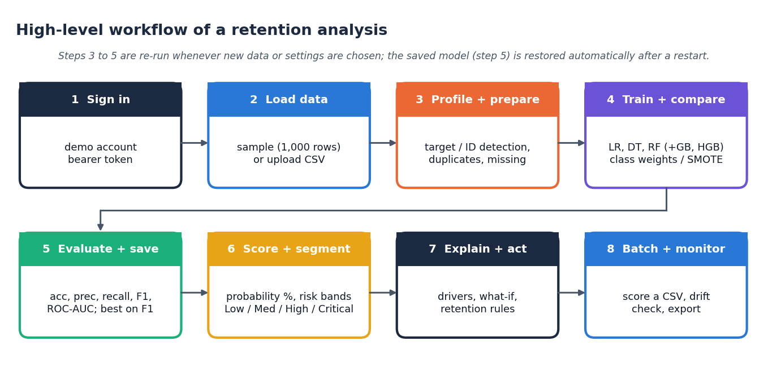
Figure 1: High-level workflow of a retention analysis in ChurnIQ

1.7 Relation to the Base Paper
The base paper, Oprea and Bara [1], proposes a unified perturbation-based explainer for churn models and compares it with SHAP and LIME on the public Telco data. This project is an applied extension of its motivation, not a reproduction of its experiments. It adopts the paper's emphasis on explaining churn predictions and its finding that contract type, monthly charges and tenure drive churn, and it builds the surrounding application: scoring, risk bands, per-customer explanation, what-if analysis and retention advice. It does not implement the paper's unified perturbation explainer, LIME, or the gradient-boosting libraries it uses, and it does not use the real Telco data; Section 8.9 sets out the differences.

1.8 Data Used and a Caution
No real operator data were available to the team. The dataset used throughout the project (data/customer_churn.csv) is therefore synthetic: 1,000 customers generated by src/sample_data.py with a fixed random seed, using the same 21-column schema as the public Telco churn data [19] and a churn rate of 26.4%. Churn is generated from a latent risk score built from contract type, tenure, payment method, services and charges, plus random noise. Models trained on it will recover those relationships, which is a useful check of the pipeline, but the metrics say nothing about accuracy on a real operator's customers. Every result in this report is labelled accordingly.

1.9 Organisation of the Report
Table 2: Organisation of the report
Chapter | Content
1 | Introduction: background, motivation, problem statement, objectives, scope
2 | Literature survey: base paper, related work, research gap
3 | Feasibility study: technical, economic, operational, schedule and risk
4 | System requirements and analysis: functional and non-functional requirements, hardware, software, use cases
5 | System design: architecture, data flow, UML, logical data model, algorithm flowchart
6 | Methodology and software implementation: pipeline, algorithms, modules, API, interface
7 | System testing: unit, integration, smoke and interface tests, defects found
8 | Results and output screens: metrics, stability, analysis, performance, base-paper comparison, screens
9 | Conclusion
10 | Future scope
 | References, Appendix A (important code), Appendix B (installation and user guide), Appendix C (additional screens)

CHAPTER 2: LITERATURE SURVEY

2.1 Approach to the Survey
The survey starts from the base paper designated for the batch and follows its citations and the related work it names towards four topics that decide the design of this project: how churn is predicted from customer records, how the resulting models are explained, how class imbalance is handled, and which classifier families suit mixed categorical and numeric data. Only papers whose bibliographic details and quoted results could be read on the paper's own page (or, for results, its abstract) are described with numbers; where only the abstract could be read this is stated in the summary table of Section 2.7.

2.2 The Base Paper
Oprea and Bara [1], "Explaining customer churn through unified perturbation-based XAI soft computing", IEEE Access, vol. 14, 2026, pose the question of which customer attributes matter most for retention and how to answer it quickly. Their method runs four perturbation-based explainers on a trained churn model: Random Noise Perturbation (RNP), which adds noise to one feature at a time and measures the drop in recall; Feature Ablation (FA), which removes a feature; Input Marginalization (IM), which replaces its values by a reference; and Adversarial Perturbation (AP), which builds adversarial examples. The four importance values are combined into one unified score, and only rows with a positive recall drop are kept.
The experiments use the public Telco customer churn data (7,043 customers, 21 columns, 26.5% churners) with a 70/30 split, so the test set has 2,113 rows. Seven classifiers are compared: Logistic Regression, SVC, Random Forest, Balanced Random Forest, CatBoost, XGBoost and LightGBM, with recall as the primary objective because a missed churner is costlier than a false alarm. The table below reproduces the metrics reported in the paper's own Table 2.
Table 3: Metrics reported in the base paper (Table 2 of [1], Telco data, 30% test)
Model | Accuracy | Recall | Precision
Logistic Regression | 0.7120 | 0.4112 | 0.6210
SVC | 0.7419 | 0.5369 | 0.6319
Random Forest | 0.7932 | 0.5634 | 0.6734
Balanced Random Forest | 0.7558 | 0.8223 | 0.6327
CatBoost | 0.6990 | 0.9077 | 0.4719
XGBoost | 0.7596 | 0.7300 | 0.5427
LightGBM | 0.7317 | 0.8293 | 0.5037

On explanation quality the paper reports high agreement between its unified perturbation score and SHAP (Spearman 0.8125, Kendall 0.7126, Jaccard 0.6885) and a large runtime advantage: about 289 s for SHAP, 35 s for LIME and 18 s for the perturbation explainers in its setting. Substantively it finds that customers on month-to-month contracts, customers with monthly charges above about $90 and customers with tenure below about 20 months are at the highest risk, and it recommends longer contracts, value-added services, personalised discounts and early engagement for new customers. In its discussion it proposes integrating the approach into a CRM as a decision-support layer and monitoring the stability of feature rankings as a drift signal.
The authors state their own limits: the conclusions are conditional on recall as the objective, the data set is a structured, moderate-dimensional table, and high-dimensional or highly correlated data may need staged or approximate ablation. The paper is a methods study; it does not describe a deployed application with scoring, risk bands and retention advice.

2.3 Churn Prediction in Telecom
Comparisons of classifiers for churn, such as Vafeiadis et al. [6], compare several machine learning techniques for churn prediction, the pattern that most later work follows: standard learners, one data set, a table of metrics. Ahmad et al. [5] apply machine learning to telecom churn on a big-data platform, which shows that the task is also a data-engineering problem at operator scale.
Recent work keeps the comparison style but adds explanation. El Attar and El-Hajj [3] compare eight models, including XGBoost, LightGBM and a soft-voting ensemble, on the same 7,043-customer Telco data with an 80/20 split and use SHAP to analyse features; they report XGBoost at accuracy 0.84 and ROC-AUC 0.932, with Logistic Regression at 0.78 and 0.864, and they caution that SHAP values describe the model's learned patterns and not causes. Rasool et al. [4] use a stacking ensemble with SHAP on a different public data set (3,333 customers) and report accuracy 94.75%, recall 73.20% and F1 80.23%. These figures are quoted as reported by the authors; the three papers use different data, splits and sometimes balanced training sets, so they cannot be ranked against one another or against this project.
Sikri et al. [2] concentrate on the data side: a ratio-based balancing step applied to imbalanced churn data, followed by single and ensemble classifiers; ensembles outperform single models and XGBoost with a 75:25 ratio gives the best result on their measures. Explainability for churn is also treated in [15], [16] and [17], which the base paper cites; Szelag and Slowinski [18] explain churn with monotonic decision rules, a rule-based route to the same goal this project pursues with its retention engine.

2.4 Explaining Predictions
SHAP [7] assigns each feature an additive contribution based on Shapley values and has a fast exact form for tree models [10]; LIME [8] fits a simple surrogate model around one prediction. Both are perturbation-based and both have known weaknesses: the base paper measures SHAP's runtime as the highest of the methods it compares, LIME's consistency as lower, and Slack et al. [9] show that such explainers can be fooled by adversarial models. For a linear model the contribution of a feature is simply its coefficient times its (standardised) value; for tree ensembles, permutation importance measures how much a score falls when one feature is shuffled. This project uses these cheaper quantities as its built-in explanations and keeps an optional SHAP code path that was not exercised in this run because the library was not installed.

2.5 Class Imbalance
Churners are a minority, 26.5% of the Telco data and 26.4% of the synthetic data used here. A classifier trained on such data tends to favour the majority class and can reach high accuracy while missing most churners; He and Garcia [12] survey the remedies. Two are used here: cost-sensitive learning through class weights, and SMOTE [11], which creates synthetic minority examples by interpolation and, to avoid leakage, is applied to the training split only. Chapter 8 measures what happens to recall when no handling is used.

2.6 Classifier Families
Logistic Regression is a transparent baseline whose coefficients can be read as effects. Decision trees give rules a business user can follow. Random forests [13] average many trees and handle mixed data and interactions with little tuning. Gradient boosting [20] builds trees sequentially on the errors of the previous ones and is the family behind the XGBoost, LightGBM and CatBoost models of the base paper. All five learners used in this project come from scikit-learn [14], which also provides the preprocessing, metrics and permutation-importance tools.

2.7 Summary of Related Work
Table 4: Summary of the surveyed work (results as reported by the authors)
Work | Approach | Data | Reported result | Limitation
Oprea and Bara, 2026 [1] (base paper) | Unified perturbation-based explainer (RNP, FA, IM, AP) compared with SHAP and LIME; LR, SVC, RF, balanced RF, CatBoost, XGBoost, LightGBM | Telco churn, 7,043 customers, 30% test (2,113) | Recall up to 0.9077 (CatBoost); Spearman 0.8125 with SHAP; runtime 18.5 s vs SHAP 289.4 s | One dataset; recall as the single objective; CRM integration proposed, not built
Sikri et al., 2024 [2] | Ratio-based data balancing as a pre-processing step; single and ensemble classifiers | Imbalanced telecom churn data (details not extracted) | Ensembles beat single models; best XGBoost at a 75:25 ratio (accuracy, precision, recall, F-score) | Abstract-level reading only; no per-customer explanation described
El Attar and El-Hajj, 2026 [3] | Eight models incl. XGBoost, LightGBM, soft-voting ensemble; SHAP feature analysis | IBM Telco, 7,043 customers, 80/20 split (1,409 test) | XGBoost accuracy 0.84, AUC 0.932; Logistic Regression 0.78 and 0.864 | Single dataset; authors note SHAP is not causal
Rasool et al., 2025 [4] | Stacking ensemble of tree models with SHAP | Kaggle Churn in Telecoms, 3,333 customers | Accuracy 94.75%, recall 73.20%, F1 80.23% | No temporal modelling; telecom data only
Lundberg and Lee, 2017 [7] | SHAP: additive Shapley-value attributions for any model | Method paper | Unifies several attribution methods | Costly on large data: 289.4 s in the experiment of [1]
Ribeiro et al., 2016 [8] | LIME: local surrogate model around one prediction | Method paper | Faithful local explanation of any classifier | Moderate fidelity and lower consistency than SHAP in [1]
Slack et al., 2020 [9] | Adversarial attacks on LIME and SHAP | Method paper | Shows perturbation-based explainers can be fooled | Perturbation-based explanations need cautious reading

2.8 Literature in the Batch Survey Document
The batch's own literature-survey file lists five works. Two of them (the base paper and Sikri et al.) are analysed above, and the remaining three could not be located by a search on their titles in the public indexes available during this run, so they are neither described nor cited here:
• Explainable Machine Learning for Telecom Customer Churn Prediction and Actionable Retention Strategies (listed as 2026, Applied Artificial Intelligence Research)
• A Novel SHAP-Guided Bayesian Optimization Method for Telecom Customer Churn Prediction and Retention (listed as 2025, IEEE EESPE)
• Enhanced Customer Retention: Deep Learning-Based Churn Prediction for Telecom Industry (listed as 2025, IJRASET)
The files that accompany the batch should be checked for the exact titles or links of these three. If they are found, they can be added to the summary table without changing the conclusions of this chapter.

2.9 Research Gap
The surveyed work compares classifiers on churn datasets and, in the base paper, concentrates on how to explain them quickly. The gap this project addresses is pairing accurate prediction with per-customer explanation so that retention action can be targeted rather than generic: a working application that scores every customer, shows the drivers of each score and maps them to concrete actions.
Four specific gaps follow from the survey:
• Most churn studies stop at a model comparison. They report a table of metrics but not an application that scores every customer and keeps the result in a form a retention team can browse.
• Explanations are usually delivered as global importance plots. A retention agent needs the drivers of one customer and the effect of changing one attribute.
• Retention advice is generally left to the reader. Few papers link the drivers to concrete actions through rules that can be audited.
• Reported numbers depend heavily on the split, the balancing and the data set, and the same pipeline gives noticeably different scores on different 200-row test sets. This project therefore reports cross-validation and repeated-split spreads next to the headline figure.
This project addresses the first three directly and the fourth by measurement. It does not try to improve on the explainers of the base paper or to beat the metrics of boosted models on real data.

CHAPTER 3: FEASIBILITY STUDY
A feasibility study asks whether the proposed system can be built and used with the resources at hand. The five aspects below are assessed with measurements from this project wherever a measurement exists and are described qualitatively where one does not; no monetary figure is invented.

3.1 Technical Feasibility
Every component is available as free, open-source software and runs on an ordinary desktop. The measurements in the table below were taken on a single machine without a graphics processor.
Table 5: Technical feasibility: measured evidence
Question | Measurement
Can the five models be trained on a desktop CPU? | Yes. All five (LR, DT, RF, GB, HGB) train and evaluate in 3.0 s on 800 training rows (Intel Core i5-12500, 15.7 GB RAM)
Can customers be scored interactively? | Yes. One customer in a median 19.07 ms (95th percentile 33.66 ms); all 1,000 customers in 35.4 ms
Is the API fast enough for a web interface? | Yes. Median response 11.6-93.8 ms for the endpoints measured over 127.0.0.1; training three models through the API takes 1.5 s
Is the software stack mature? | Python 3.11, scikit-learn, pandas, FastAPI, React 19 and Vite 8 are widely used and documented
Can the pipeline be tested? | Yes. 44 unit tests and a 63-check end-to-end API test pass

3.2 Economic Feasibility
The software cost is zero: no commercial licence, cloud service or paid API is used, and the retention advice is produced by local rules, not by a paid language model. The only hardware needed is a computer that can run Python; the development machine was an ordinary desktop. Operating cost is limited to the time of the analyst who uses it.
The benefit side is the value of the customers retained. Industry sources describe acquisition as several times more costly than retention, but this project has no campaign or revenue data, so it does not estimate a monetary saving. What it can support is an indication of targeting value: on the test split, contacting the 20% of customers with the highest scores reached 39.6% of the churners, a lift of about 2 over random contact (Section 8.8). Whether that justifies the cost of a campaign depends on the cost per contact and the value per saved customer, which are operator-specific inputs.

3.3 Operational Feasibility
• Usability. The interface needs no programming. The pages follow the workflow (Data, Train, Evaluate, then the analysis pages), and each page says what it needs when a step is missing.
• Skills. An analyst who can read a metrics table and a bar chart can use every page; the explanations are phrased in business terms (for example, "Contract: Month-to-month pushes the score up").
• Deployment. One script (run.bat) creates the virtual environment, installs the packages and starts the API (port 8314) and the web interface (port 5314). The original Streamlit application starts with one command.
• Data handling. The system works on a CSV file. A new CSV is validated and rejected with a plain message if columns are missing.

3.4 Schedule Feasibility
The work was organised in phases that depend on one another. The table lists them in order; calendar dates are not given because the batch records do not include a dated plan.
Table 6: Project phases
Phase | Activity | Output
1 | Problem definition, base paper study, literature survey | Abstract, objectives, survey
2 | Data preparation and exploratory analysis | Cleaned data, EDA pages
3 | Model training, imbalance handling and evaluation | Model comparison, saved model
4 | Risk bands, explanations, what-if, retention rules | Customer 360, XAI, retention pages
5 | Batch scoring, monitoring, API layer and React interface | FastAPI service, ChurnIQ interface
6 | Testing, experiments and documentation | Tests, metrics, report, decks, paper

3.5 Legal, Ethical and Data-Protection Feasibility
The data used in this project are synthetic and contain no personal information, so no consent or anonymisation was needed. In real use, customer records are personal data: processing them for churn scoring needs a lawful basis, access control and retention limits under the data-protection rules that apply to the operator. The demo login in this project is a convenience for demonstration and is not an access-control system for real customer data.
There is also an ethical point about retention offers. A score is a ranking that can be wrong, and the explanations are model attributions, not causes (the base paper and the surveyed work say the same). The retention rules therefore phrase their output as suggestions to "consider" and never trigger an action automatically.

3.6 Risk Analysis
Table 7: Project risks and mitigation
Risk | Effect | Mitigation in this project
No real operator data | Metrics do not transfer to a real customer base | Synthetic data are declared in every document; the pipeline accepts any CSV with the Telco schema
Small test set (200 rows, 53 churners) | Single-split metrics are noisy (sd 0.03-0.10) | 5-fold cross-validation and five repeated splits are reported beside the headline figure
Class imbalance | High accuracy, low recall | Class weights or SMOTE; model chosen on F1, not accuracy; recall measured with and without handling
Uncalibrated probabilities | A score of 60 is not a 60% chance | Scores are described as rankings; calibration is measured and reported (Section 8.8)
Optional SHAP library missing | No SHAP explanations | Coefficient-times-value and permutation importance fall back automatically; SHAP is stated as not demonstrated
Library version differences | Tree-ensemble scores change on a 200-row split | Environment of record stated; a second environment is archived (Section 8.3)
Single-user in-memory state | No concurrent users; dataset lost on restart | Documented limitation; the active model is restored from disk

3.7 Conclusion of the Feasibility Study
The system is technically feasible (measured), economically feasible in terms of cost (no licences, ordinary hardware), operationally feasible for a non-programmer, and acceptable from a legal and ethical point of view when used on properly governed data. Its main risk is not the build but the evidence: the metrics come from synthetic data and a small test set, and must be re-measured on real data before any operational decision rests on them.

CHAPTER 4: SYSTEM REQUIREMENTS AND ANALYSIS

4.1 Functional Requirements
The functional requirements were derived from the objectives (Section 1.4) and from the way a retention analyst works. Each requirement is implemented by a page of the application and one or more API routes.
Table 8: Functional requirements
ID | Requirement | Implemented by
FR1 | Sign in with a demo account; reject wrong or expired credentials | Sign in page; POST /api/auth/login, bearer token
FR2 | Load the sample data or upload a customer CSV; preview rows | Data page; /api/data/sample, /upload, /preview
FR3 | Detect or set the target and ID columns; report data quality (types, missing values, duplicates) | Data page; /api/data/config, /quality
FR4 | Clean the table and build the feature set | Data page; /api/data/prepare
FR5 | Explore churn by segment and numeric field with filters | Explore page; /api/eda
FR6 | Train the required models (LR, DT, RF) and optional models (GB, HGB) with a chosen imbalance strategy and test size | Train page; /api/models/train
FR7 | Show accuracy, precision, recall, F1, ROC-AUC, confusion matrix, ROC and precision-recall curves; recommend the best model | Evaluation page; /api/evaluation
FR8 | Save the chosen model and restore it after a restart | Evaluation page; /api/models/save; models/*.pkl
FR9 | Show portfolio KPIs and risk distribution | Dashboard; /api/dashboard
FR10 | Group customers into Low, Medium, High and Critical risk with editable, validated thresholds | Customer risk page; /api/risk, /api/risk/thresholds
FR11 | Show one customer's profile, score, drivers and actions (Customer 360) | Customer 360; /api/customers/{id}
FR12 | Explain the model globally and each prediction locally | Explain page; /api/xai/global, /api/xai/local/{id}
FR13 | Re-score a customer after attribute changes (what-if) | What-if page; /api/whatif
FR14 | Generate rule-based retention actions per customer and for a risk group | Retention page; /api/retention
FR15 | Score a new CSV and download the result; reject files with missing columns | Batch page; /api/batch/template, /predict
FR16 | Show the active model's details and check new data for drift | Monitoring page; /api/monitoring, /drift

4.2 Non-Functional Requirements
Table 9: Non-functional requirements and how they are met
Quality | Requirement | Evidence
Performance | Interactive response on a desktop | Median API response 11.6-93.8 ms; single score 19.07 ms
Usability | Usable without programming; clear errors | Guided pages; 422 / 409 messages in plain language; light and dark themes; keyboard focus and skip link
Reliability | Invalid input never crashes the service | Server-side validation of thresholds, columns and file type; 63-check smoke test includes the error paths
Security | No open endpoints except health and login | HMAC-SHA256 signed bearer token with 12 h expiry; credentials in .env; protected routes return 401
Portability | Runs on Windows and any system with Python 3.11 | requirements.txt; run.bat; no GPU or external service
Maintainability | Core logic independent of the interface | src/ has no UI imports; FastAPI layer only calls src/; 44 unit tests
Reproducibility | Same numbers on re-run | Fixed seed 42; scripts/run_experiments.py writes metrics.json; environment recorded

4.3 Hardware Requirements
Table 10: Hardware
Item | Minimum | Used in this project
Processor | Dual-core 2 GHz | Intel Core i5-12500 (6 cores, 12 threads)
Memory | 4 GB | 15.7 GB
Storage | 1 GB free (environment, node packages, data) | SSD
Graphics | Not required | Not used (CPU only)
Display | 1280 x 720 | 1440 x 900 used for screenshots; layouts checked at 360, 768 and 1440 px

The minimum column is a conservative estimate for a 1,000-row data set and was not tested on smaller machines.

4.4 Software Requirements
Table 11: Software
Component | Version / note
Operating system | Windows 11 (run.bat); the Python parts also run on Linux and macOS
Python | 3.11.9
scikit-learn / pandas / numpy | 1.9.1 / 3.0.6 / 2.4.6 in the environment of record (the same code also passes its tests on 1.5.0 / 2.2.1 / 1.26.4)
imbalanced-learn, joblib | SMOTE oversampling; saving and loading model files
Streamlit, plotly | Original 13-page application and its charts
FastAPI, uvicorn | 0.143.3 and 0.54.0: API layer, port 8314, interactive docs at /docs
Node.js | 24.19.0, for the web interface build
React, Vite, React Router, Recharts | 19.3, 8.3, 7, 3: ChurnIQ interface, port 5314
pytest | 9.1.1: unit tests
Optional: SHAP | Not installed; the code falls back to built-in explanations

4.5 Data Requirements
The system expects one row per customer with the columns below (the 21-column Telco schema). The target is detected from a column named Churn (or a similar name) and the identifier from a column such as customerID; both can be changed on the Data page. Rows with exact duplicates are removed, blanks in numeric-looking text columns are converted to missing values, and missing values are imputed inside the pipeline.
Table 12: Data fields
Field(s) | Type | Meaning
customerID | text | Unique customer identifier (detected automatically; excluded from the features)
gender | category | Female / Male
SeniorCitizen | numeric 0/1 | Customer is a senior citizen
Partner, Dependents | category | Yes / No
tenure | numeric | Months with the company (0-72 in the sample)
PhoneService, MultipleLines | category | Phone service taken; multiple lines (or no phone service)
InternetService | category | DSL / Fiber optic / No
OnlineSecurity, OnlineBackup, DeviceProtection, TechSupport, StreamingTV, StreamingMovies | category | Yes / No / No internet service
Contract | category | Month-to-month / One year / Two year
PaperlessBilling | category | Yes / No
PaymentMethod | category | Electronic check / Mailed check / Bank transfer (automatic) / Credit card (automatic)
MonthlyCharges | numeric | Monthly bill (18.00-105.97 in the sample)
TotalCharges | numeric | Total billed to date (1.15-6,747.02 in the sample)
Churn | target Yes/No | Whether the customer left (detected automatically)

The sample file has 1,000 rows and no missing values or duplicates; 19 raw feature columns (4 numeric, 15 categorical) become 45 model inputs after one-hot encoding.

4.6 Actors and Use Cases
There is a single role, the retention analyst, who also trains models when needed; the demo account is shared and there are no permissions to separate duties. The use-case diagram shows the fifteen use cases. Sign in precedes all others; training precedes saving, risk analysis, explanation, what-if and retention.
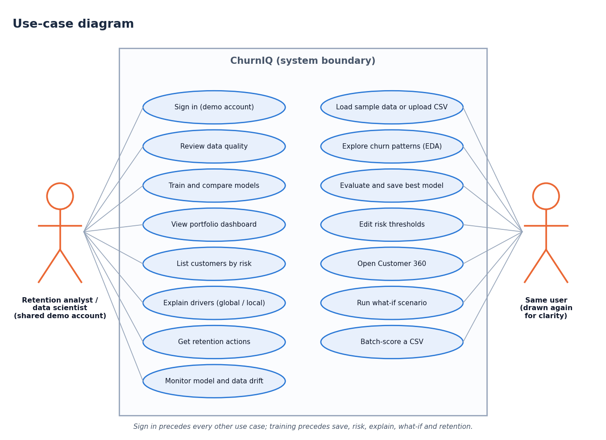
Figure 2: Use-case diagram of ChurnIQ
Table 13: Main use cases
Use case | Precondition | Main flow | Result
Train and compare models | Data prepared | Choose models, strategy, test size; start training | Metrics table, curves, recommended model
Open Customer 360 | Model saved | Select a customer from the risk list | Profile, score, band, drivers, actions
Run what-if | Model saved | Change contract, charges or add-ons; re-score | Original and new score side by side
Batch-score a CSV | Model saved | Upload CSV with required columns | Scored table, download; 422 if columns missing
Check drift | Model saved | Upload new data | Missing columns, missingness, unseen categories, mean shift, churn rate

4.7 Analysis of the Data
The sample has 736 retained and 264 churned customers, an imbalance of 2.79 to 1. A classifier that predicted "stays" for everyone would be 73.6% accurate and find no churner, which is why accuracy is not used alone to choose the model.
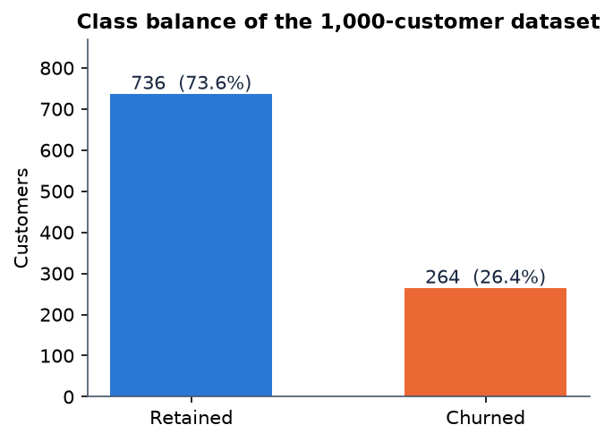
Figure 3: Class balance of the customer data
Churn varies strongly with a few attributes, as the figure below shows. Month-to-month customers churn at 34.1% against 19.2% for one-year and 12.5% for two-year contracts; customers in their first year churn at 36.6% against 18.7% after four years; fibre-optic customers churn more (32.7%) than DSL (25.1%) or no-internet customers (14.7%); and electronic-check payers churn at 33.4% against 18.3% for automatic bank transfer. These are the relationships built into the generator, so they confirm that the analysis reads the data correctly, not that real customers behave this way.
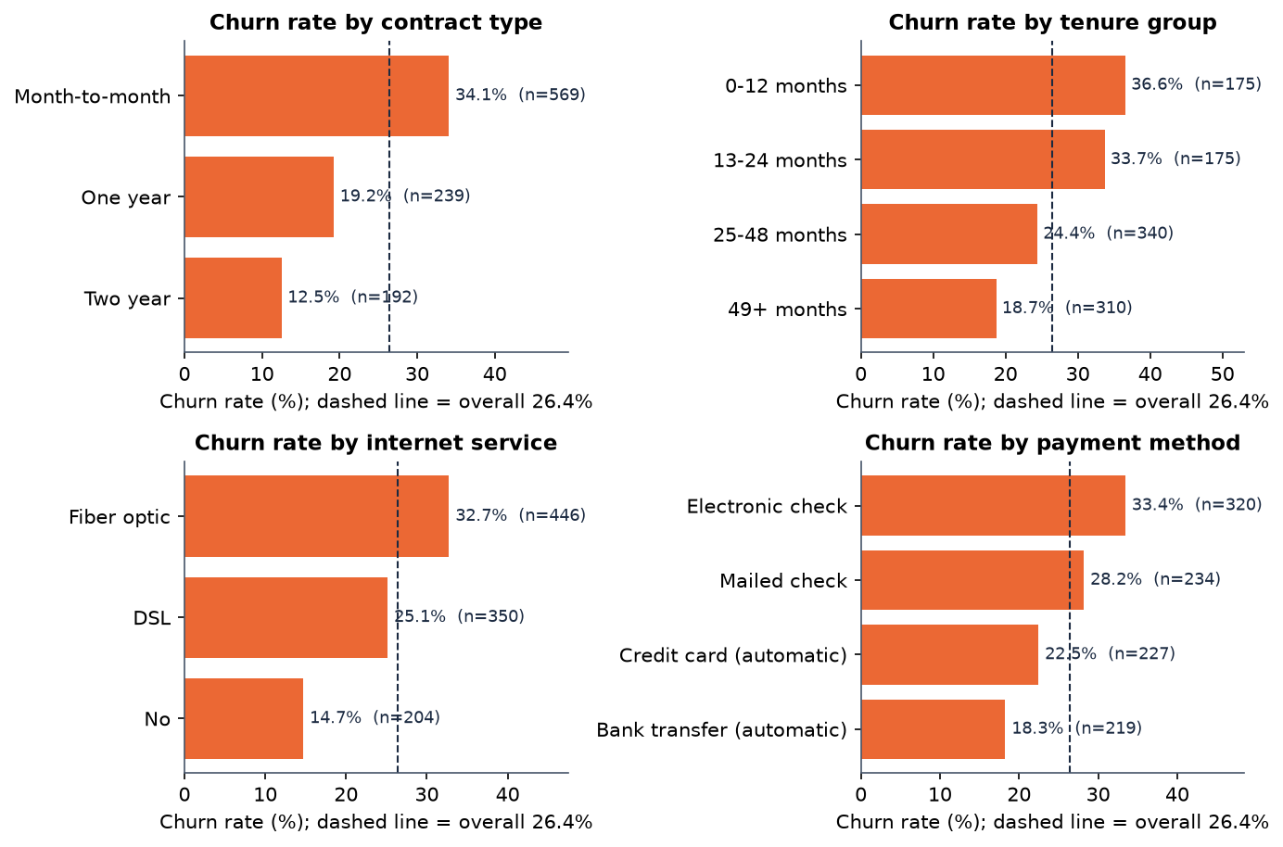
Figure 4: Churn rate by contract type, tenure group, internet service and payment method
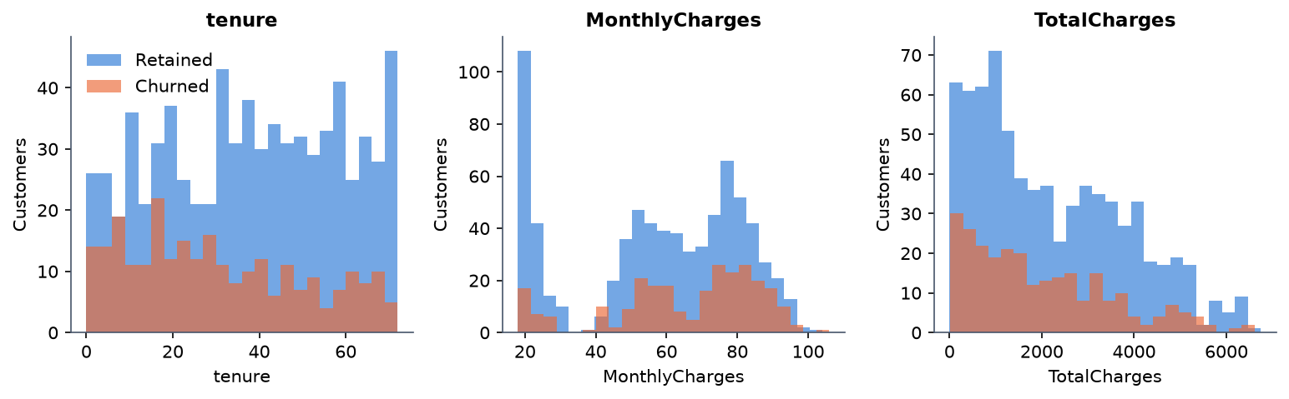
Figure 5: Distribution of tenure, monthly charges and total charges for retained and churned customers

4.8 Assumptions and Constraints
• One analyst works at a time; state is held in memory and is not shared between users.
• The input has the Telco schema; other schemas work as long as a binary target is present, but the retention rules read the Telco field names and stay silent on other fields.
• The churn label is available for training; the system does not infer churn from usage.
• Probabilities are model scores, not calibrated chances of leaving (Section 8.8).
• Only scikit-learn models are used; no deep learning and no external gradient-boosting library.

CHAPTER 5: SYSTEM DESIGN

5.1 Design Principles
• Core independent of the interface. All data, modelling and business logic lives in src/ and imports nothing from Streamlit or FastAPI. The Streamlit pages and the FastAPI routes are thin callers, so the two interfaces cannot disagree.
• Explainable by construction. Every score can be traced: coefficients or importances for the model, a list of drivers for the customer, a named rule for each retention suggestion.
• Honest evaluation. The preprocessor is fitted on the training split only, SMOTE touches only the training split, and the best model is chosen on F1 and not on accuracy alone.
• Fail early and clearly. Settings and uploads are validated on the server and rejected with a plain message (401, 404, 409, 422) before any computation starts.
• No hidden services. Nothing leaves the machine: no external API, no language model, no database server.

5.2 System Architecture
The system has four layers. The presentation layer is the React interface (port 5314, which proxies /api to the API) and the original Streamlit interface (port 8501). The application layer is the FastAPI service in backend/ with 31 route handlers, bearer-token authentication and an in-memory AppState. The core layer is the pure-Python package src/, which both interfaces call and which contains no interface code. The data layer is the CSV file, the three joblib files of the saved model and the in-memory state. There is no SQL database.
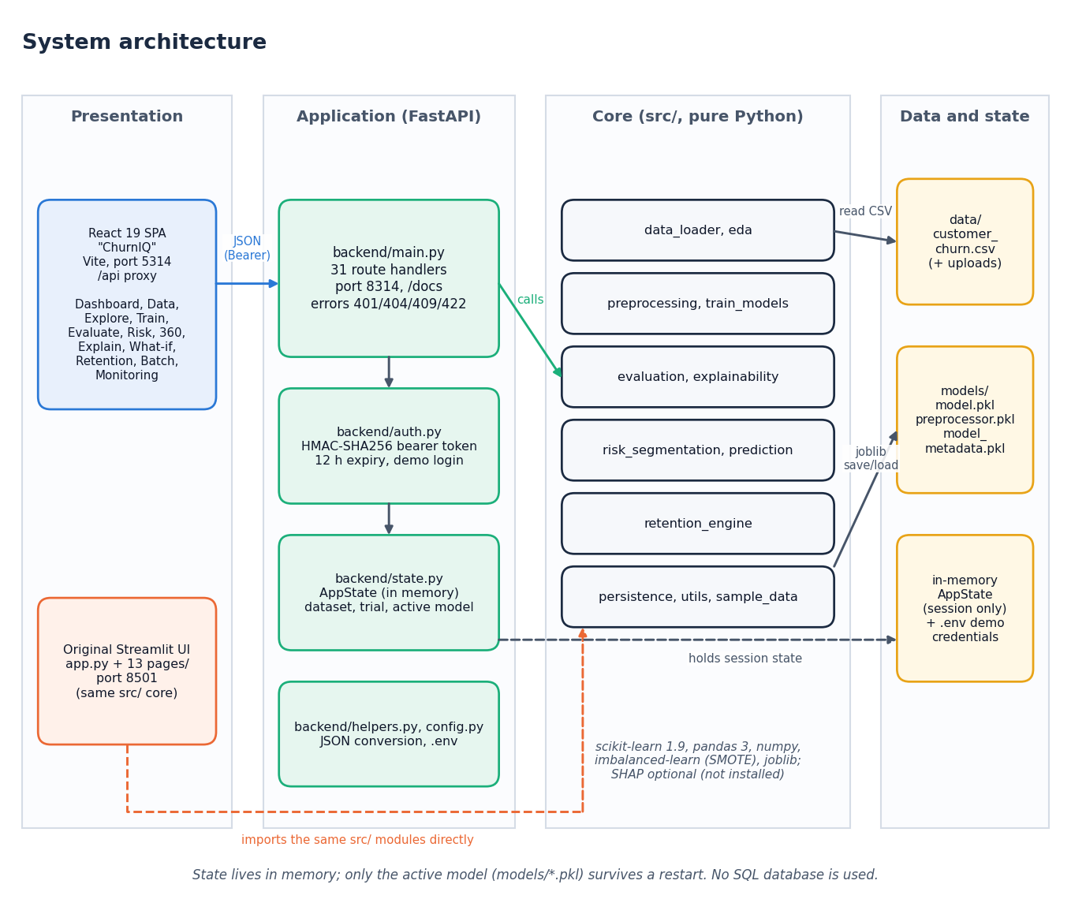
Figure 6: System architecture of ChurnIQ
The code base has about 1,183 lines in src/ (12 modules), 1,052 lines in backend/, 1,353 lines in the 13 Streamlit pages and the React interface in frontend/. The FastAPI layer was added for the web interface and changes nothing in src/.

5.3 Module Design
Table 14: Modules of the core package src/
Module | Lines | Responsibility
data_loader.py | 180 | Read a CSV; detect target and ID columns; coerce numeric-looking text; profile (missing, duplicates, warnings); normalise the target to 0/1; validate before training
preprocessing.py | 102 | Drop duplicates; stratified train/test split; ColumnTransformer (median + StandardScaler, most-frequent + OneHotEncoder); SMOTE on the training split
train_models.py | 93 | MODEL_REGISTRY (LR, DT, RF, GB, HGB); train the selected models under an imbalance strategy; select the best model on a chosen metric
evaluation.py | 56 | Accuracy, precision, recall, F1, ROC-AUC, confusion matrix, ROC and precision-recall curves
explainability.py | 169 | Global importance (built-in, permutation, optional SHAP); local explanation with a coefficient-times-value fallback; readable feature labels
risk_segmentation.py | 49 | Score every customer, assign risk bands, sort, summarise the distribution
prediction.py | 63 | Score customers; validate batch columns; build the batch prediction table with optional top drivers
retention_engine.py | 137 | Ten IF/THEN rules plus two fallbacks that turn a profile, probability and band into retention suggestions
persistence.py | 41 | Save and load model.pkl, preprocessor.pkl and model_metadata.pkl with joblib
eda.py | 98 | KPIs and the charts of the Explore page
sample_data.py | 120 | Seeded synthetic Telco-style data generator
utils.py | 75 | Risk-band assignment from editable thresholds; tenure and charge groups; safe numeric coercion

The API layer has five modules: main.py (route handlers), auth.py (token creation and checking), state.py (the in-memory AppState), helpers.py (conversion of pandas and numpy values to JSON) and config.py (settings read from .env).

5.4 Data Flow
One process, the ChurnIQ system, exchanges data with the analyst and with the customer data source and uses three stores: the working dataset and session state, which are in memory, and the model files on disk.
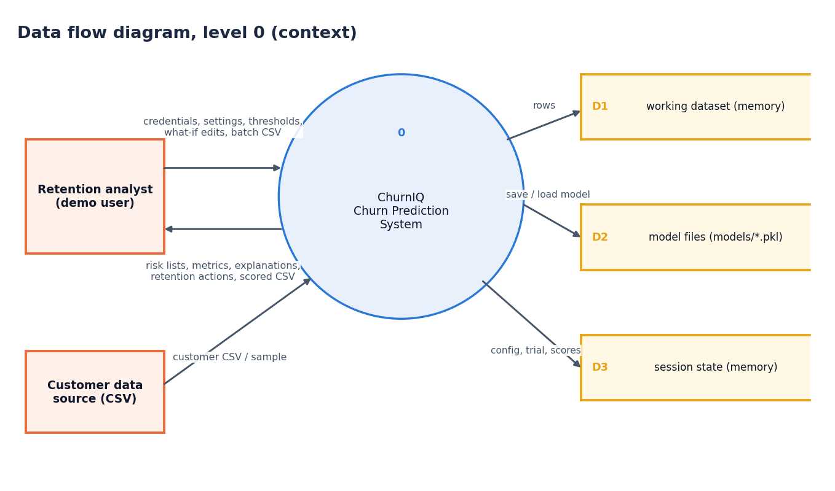
Figure 7: Data flow diagram, level 0 (context)
Six processes: authenticate (1.0), load, profile and prepare (2.0), train, evaluate and select (3.0), score and segment risk (4.0), explain, what-if and retention (5.0) and batch scoring and monitoring (6.0). The model artefacts written by 3.0 and read by 4.0 and 6.0 are the link between training and use.
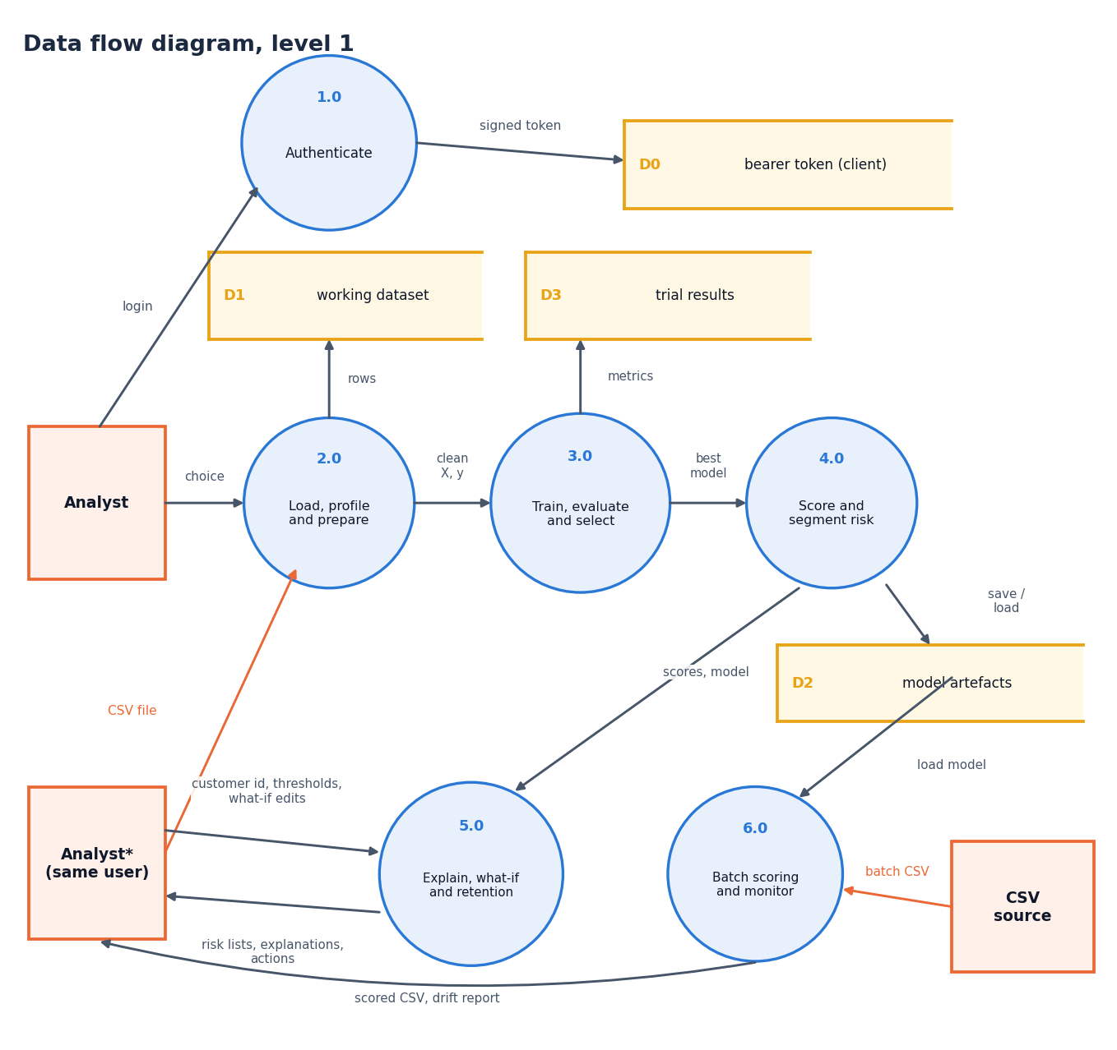
Figure 8: Data flow diagram, level 1
Process 3.0 expanded into seven sub-processes: stratified split, preprocessor fit on the training split only, imbalance handling, model fitting, evaluation on the test split, selection of the best model and saving of the artefacts. SMOTE touches only the training split.
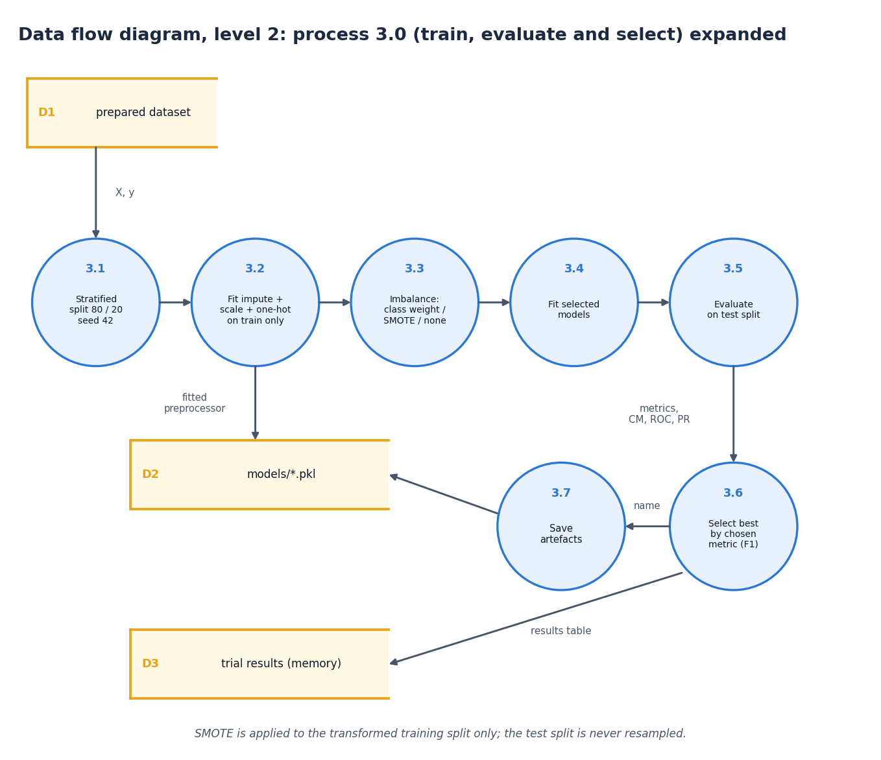
Figure 9: Data flow diagram, level 2: train, evaluate and select

5.5 Class and Sequence Design
The code base is function-oriented, so the diagram draws each module of src/ and backend/ as a class with the data it holds and the operations it offers. AppState is the only real class (a dataclass) and owns the dataset, the trial results, the active model and the risk thresholds. Arrows show which module uses which.
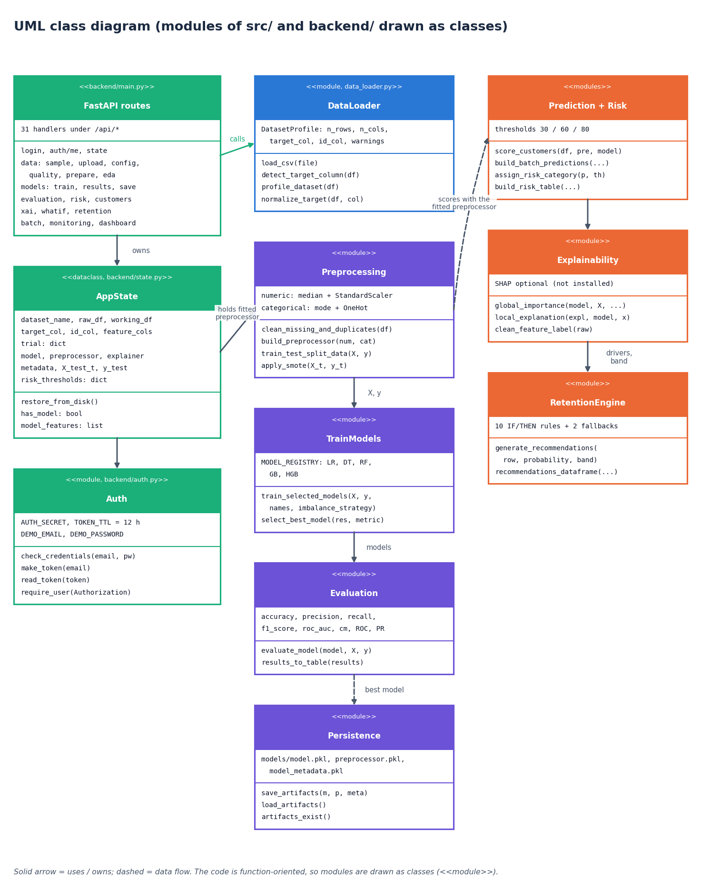
Figure 10: UML class diagram (modules drawn as classes)
The messages exchanged when an analyst signs in, loads and prepares the sample, trains and saves a model and then opens one customer. The API validates the token on every call after the login and returns the error codes listed at the foot of the figure.
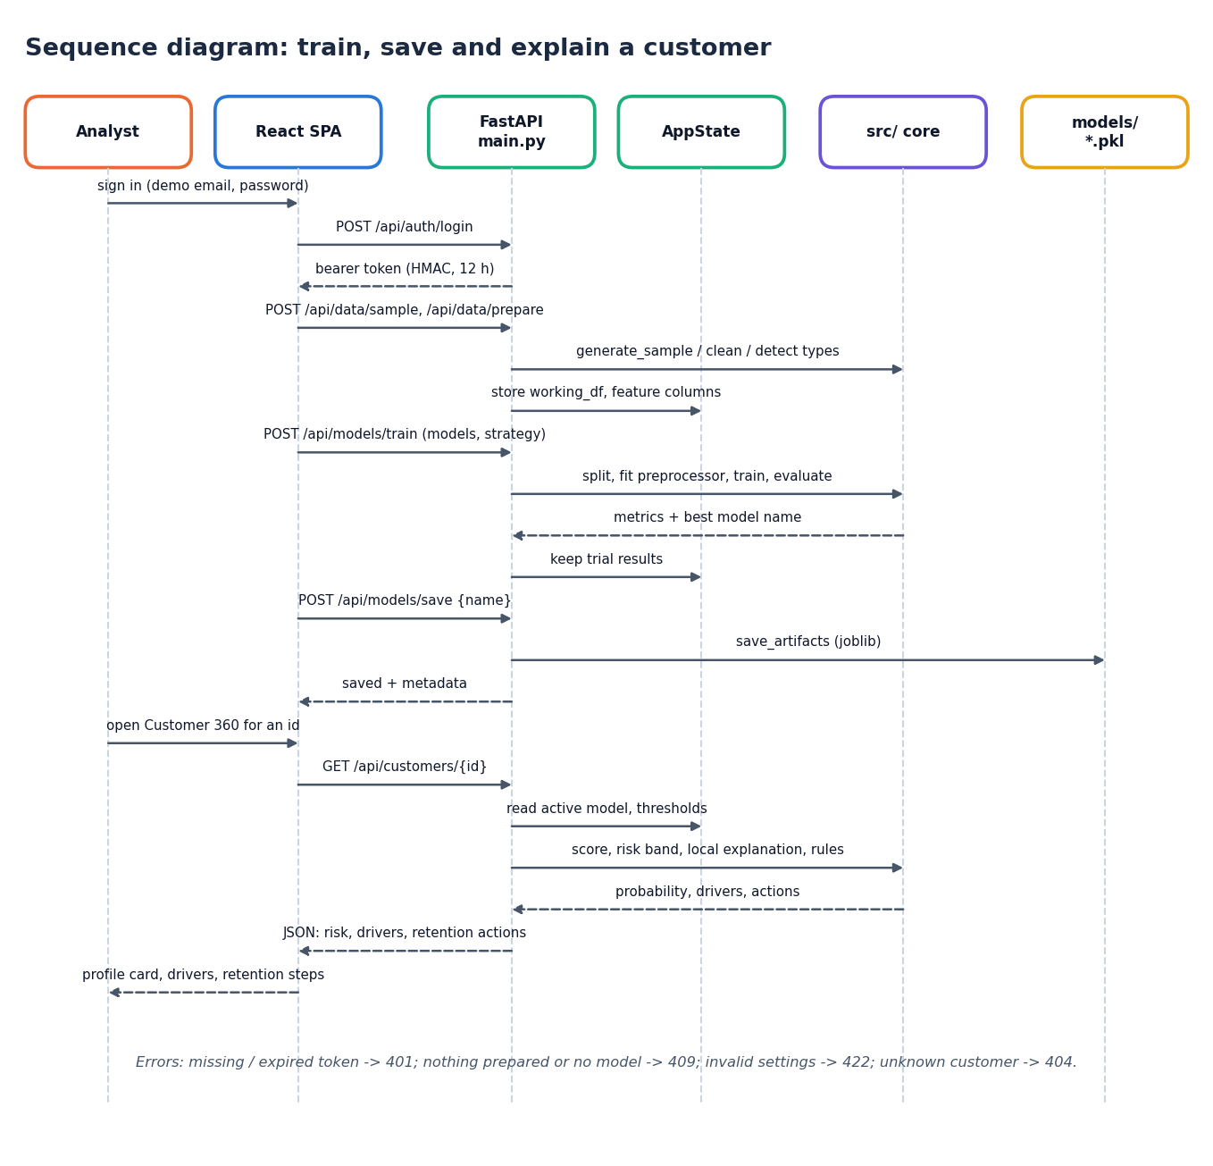
Figure 11: Sequence diagram: sign in, train, save and open Customer 360

5.6 Logical Data Model
The project has no database, so this is the logical data model of the entities the code handles: the dataset and its customers, the trial runs, the saved model artefact, the risk record of each customer, the thresholds and the recommendations. Relationships and keys are those of the in-memory tables and the files on disk.
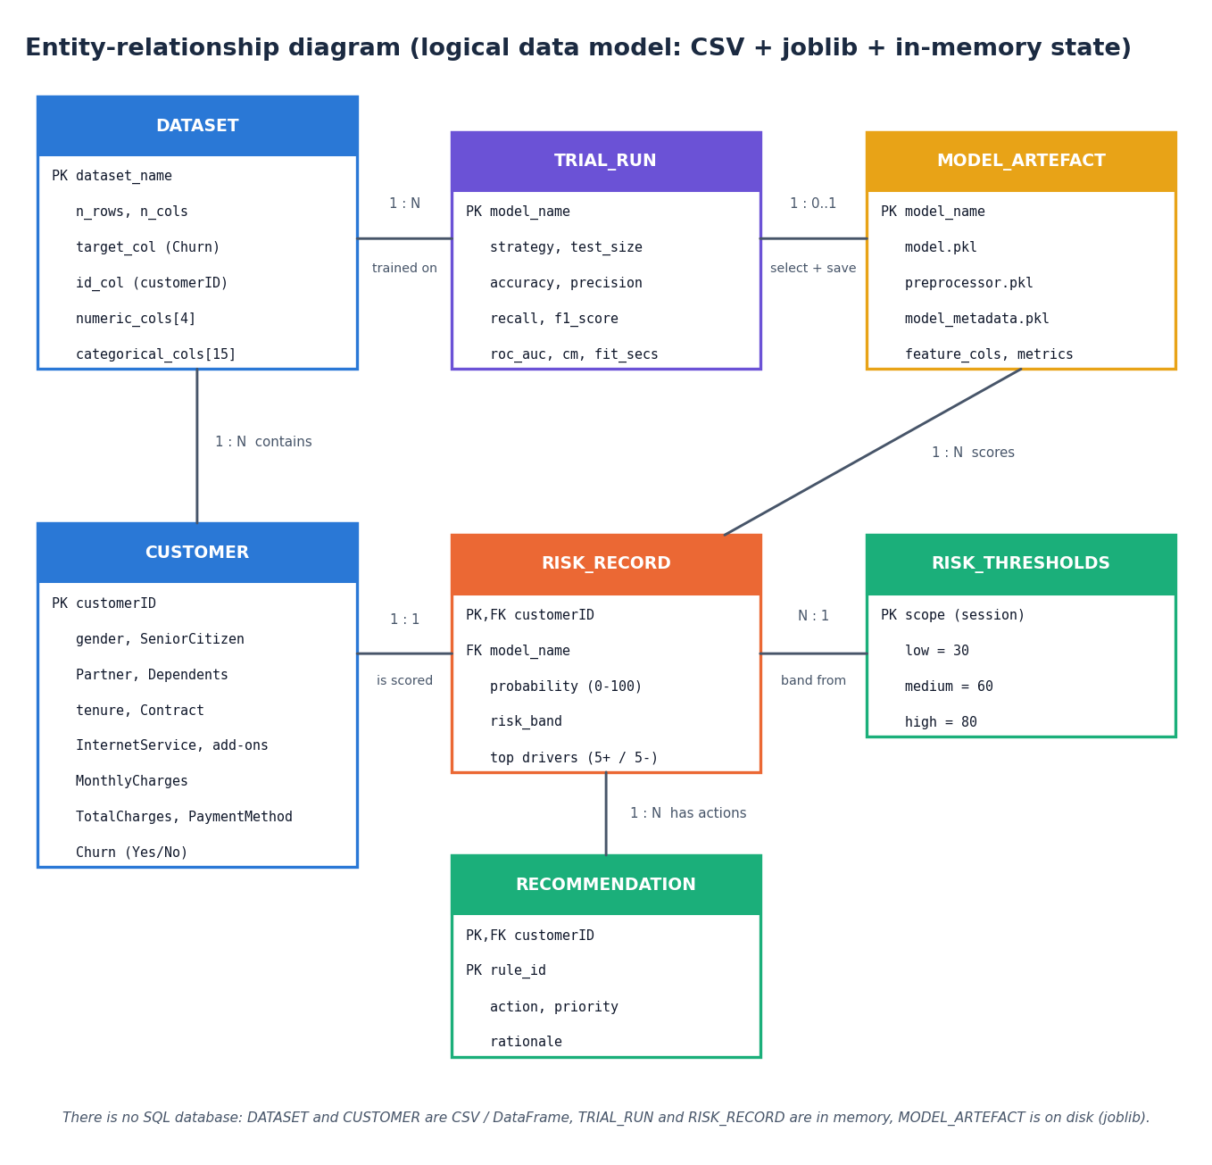
Figure 12: Entity-relationship diagram (logical data model)
Table 15: Entities of the logical data model
Entity | Where it lives | Key and content
DATASET | DataFrame in AppState; CSV on disk | Name, row and column counts, target and ID columns, lists of numeric and categorical columns
CUSTOMER | Rows of the DataFrame | customerID; the 19 feature columns; Churn
TRIAL_RUN | AppState.trial (memory) | Model name, imbalance strategy, test size, five metrics, confusion matrix, fit time
MODEL_ARTEFACT | models/model.pkl, preprocessor.pkl, model_metadata.pkl | Model name, fitted model and preprocessor, feature columns, feature names, metrics
RISK_RECORD | Computed on demand | customerID, probability 0-100, risk band, top drivers
RISK_THRESHOLDS | AppState.risk_thresholds | low 30, medium 60, high 80 by default; editable and validated
RECOMMENDATION | Computed on demand | Rule name, suggestion, linked to a customer

5.7 Algorithm Design
The decisions of the pipeline: validate the data, choose the imbalance strategy, fit and evaluate the models, select and save the best, score customers, and apply the retention rules to customers at or above 60%.
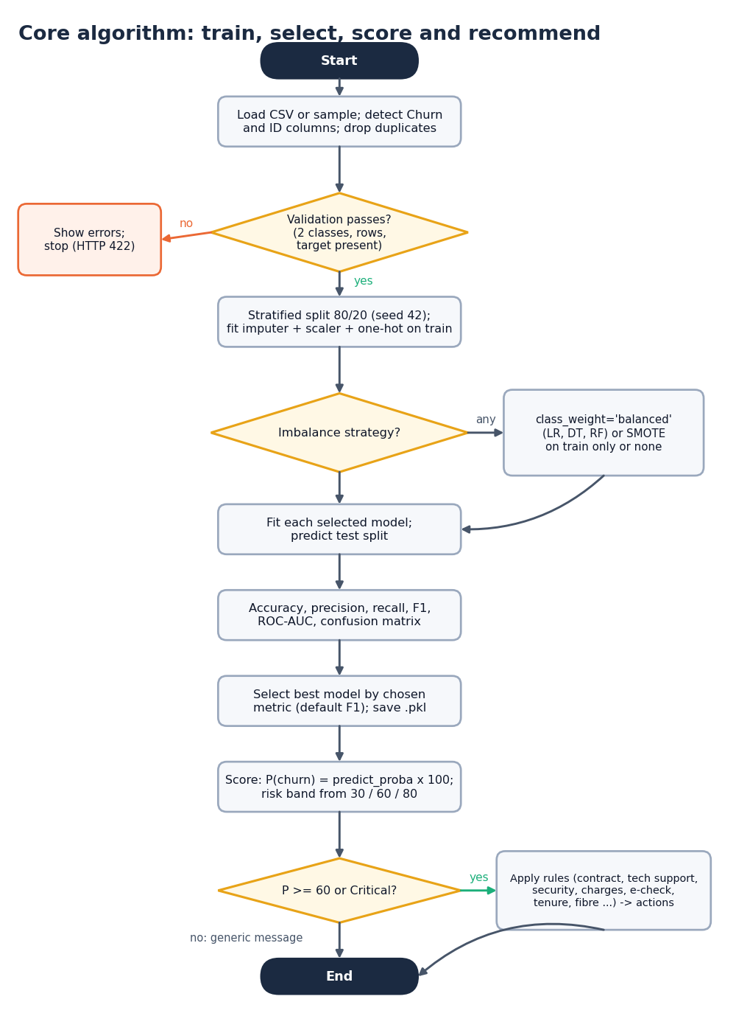
Figure 13: Flowchart of the core algorithm: train, select, score and recommend
Chapter 6 gives each step in detail. Two design decisions are worth stating here. First, model selection uses F1 by default (user-selectable among accuracy, precision, recall, F1 and ROC-AUC), because on 26% churn a model that never predicts churn has 74% accuracy. Second, the rule-based retention step is gated at 60%: nine of the ten rules require a probability of at least 60 (the High or Critical band at default thresholds) and the tenth requires the Critical band, so that low-risk customers are not sent offers.

5.8 API Design
The API follows REST conventions: nouns in paths, GET for reads, POST for actions that compute or change state, PUT for settings. All routes except health and login need an Authorization: Bearer header. Interactive documentation is served at /docs. Errors use four codes with a plain-language detail field: 401 for a missing or expired token, 404 for an unknown customer, 409 when the data or the model is not ready, and 422 for invalid input.
Table 16: API routes by group (31 handlers)
Group | Routes | Purpose
Health, auth | GET /api/health; POST /api/auth/login; GET /api/auth/me; GET /api/state | Public: health and login. Others need a bearer token
Data | POST /api/data/sample, /upload; GET /api/data/preview; GET, PUT /api/data/config; GET /api/data/quality; POST /api/data/prepare | Load, configure, check, prepare
Exploration | GET /api/eda; GET /api/dashboard | Charts, KPIs, portfolio summary
Models | POST /api/models/train; GET /api/models/results; POST /api/models/save; GET /api/evaluation | Train, compare, save, evaluate
Risk | GET, PUT /api/risk/thresholds; GET /api/risk; GET /api/customers; GET /api/customers/{id} | Bands and Customer 360
Explanation | GET /api/xai/global; GET /api/xai/local/{id}; GET /api/whatif/schema; POST /api/whatif | Drivers and scenarios
Retention | GET /api/retention | Rule-based actions
Batch, monitoring | GET /api/batch/template; POST /api/batch/predict; GET /api/monitoring; POST /api/monitoring/drift | Scoring a new CSV; drift

5.9 State and Persistence Design
AppState mirrors Streamlit's st.session_state for a single user: the raw and working data frames, the detected columns, the last training comparison (trial), the active model, its preprocessor and metadata, the cached explainer and importances and the risk thresholds. A re-entrant lock protects it because FastAPI may handle requests on several threads. Only the active model is persisted: save_artifacts writes three joblib files, and restore_from_disk loads them when the service starts. The dataset and the comparison table are session-only, as in the Streamlit application.

5.10 Security Design
• Demo credentials come from .env (DEMO_EMAIL, DEMO_PASSWORD) and are compared in constant time.
• The token is base64(payload).HMAC-SHA256(payload) with an expiry claim (12 hours); tampering or expiry makes read_token return nothing and the route answers 401.
• Uploads are accepted only as CSV and are parsed in memory; thresholds are validated server-side (Low 5-50, Medium at least 5 points above Low and at most 85, High at least 5 points above Medium and at most 95).
• This is a demonstration login with one shared account. It is not a substitute for real authentication, authorisation or audit logging on real customer data.

5.11 User-Interface Design
The ChurnIQ interface has a landing page, a demo sign-in and thirteen working pages arranged in the order of the workflow. It follows a soft pastel design kit with light and dark themes, a skip-to-content link, visible keyboard focus, reduced-motion support and layouts checked at 360, 768 and 1440 px. Each page states what it needs when a step is missing and shows plain-language errors returned by the API. The pages are shown in Chapter 8 and Appendix C.

CHAPTER 6: METHODOLOGY AND SOFTWARE IMPLEMENTATION

6.1 Overview of the Methodology
The method is a supervised-learning pipeline wrapped in an explanation and action layer. Thirteen steps run in order; the first eight are executed once per data set (training time), the last five for each customer or batch (scoring time).
1. Load and profile. Read the CSV, detect the target (Churn) and ID (customerID) columns, convert numeric-looking text columns, and report types, missing values and duplicates.
2. Clean. Drop exact duplicate rows; keep missing values for the pipeline to impute.
3. Split. Stratified 80/20 train/test split with random_state 42 (test size selectable from 10% to 40%).
4. Preprocess. Fit a ColumnTransformer on the training split only: median imputation and standardisation for numeric fields, most-frequent imputation and one-hot encoding (unseen categories ignored) for categorical fields.
5. Handle imbalance. Class weights (default), SMOTE on the transformed training split only, or no handling.
6. Train. Logistic Regression, Decision Tree and Random Forest (required); Gradient Boosting and Histogram Gradient Boosting (optional).
7. Evaluate. Accuracy, precision, recall, F1-score, ROC-AUC, confusion matrix, ROC and precision-recall curves on the untouched test split.
8. Select and save. Choose the best model on the selected metric (F1 by default); save the model, preprocessor and metadata to models/.
9. Score. Churn probability = predict_proba x 100 for every customer.
10. Segment. Assign Low, Medium, High or Critical risk from editable thresholds (30 / 60 / 80 by default).
11. Explain. Global importance of features and, for one customer, the drivers that push the score up and down.
12. Recommend. Apply the retention rules to customers at or above 60%.
13. Monitor. Score new files in batch and compare new data with the training data for drift.

6.2 Data Acquisition and Loading
The sample data are produced by generate_sample_churn_data(n_customers=1000, random_state=42). The generator draws the 21 Telco-style fields with realistic proportions (for example 55% month-to-month contracts, 44% fibre-optic, 34% electronic check) and sets churn from a latent logistic risk score: month-to-month contract adds risk, long tenure reduces it, electronic check, fibre optic, missing tech support and online security and higher charges add risk, and Gaussian noise (standard deviation 0.55) is added before the label is drawn. The resulting churn rate is 26.4%. The generator exists so that the application can be demonstrated without a data file; it is not a model of any real operator.
An uploaded file is read with pandas. The target is found by name (churn, target, label, exited, is_churn or churned, in any case) and the identifier by name (customerID, customer_id, id, custid) or, as a fallback, as a text column whose values are all unique. A text column whose name suggests money (TotalCharges, MonthlyCharges, charges, amount) is converted to numbers; blank strings, which occur in the public Telco file, become missing values. The target is normalised to 0/1: the strings yes, 1, true, churned, churn and y (any case) are positive, everything else is negative. validate_dataset_for_training refuses an empty table, a missing target, fewer than 30 rows, a single class or a class with fewer than 5 examples before any model is trained.

6.3 Cleaning, Preprocessing and Splitting
Exact duplicate rows are dropped (none in the sample). The remaining columns are split into numeric (SeniorCitizen, tenure, MonthlyCharges, TotalCharges) and categorical (15 fields). The ColumnTransformer treats them differently because the models need numbers and because categories have no order:
Table 17: Preprocessing of the feature types
Type | Fields | Steps
Numeric | SeniorCitizen, tenure, MonthlyCharges, TotalCharges | Median imputation, then StandardScaler (z = (x - mean) / sd)
Categorical | 15 fields (gender, Partner, ..., PaymentMethod) | Most-frequent imputation, then one-hot encoding with handle_unknown = ignore

After encoding, the 19 raw features become 45 numeric inputs. The preprocessor is fitted on the training split only and applied to the test split, so no test information reaches the models. The split is stratified, so training and test sets keep the churn proportion: with test size 0.20 and seed 42 the sample gives 800 training rows (211 churners) and 200 test rows (53 churners). Unseen categories at scoring time are ignored (all-zero one-hot) instead of raising an error.

6.4 Handling Class Imbalance
Three strategies are offered, and the Train page lets the analyst choose one. Class weights make an error on the rare class cost more: for the Logistic Regression, Decision Tree and Random Forest the weight of a class is n / (2 x n_class). On the training split this is 1.896 for churners and 0.679 for retained customers. Gradient Boosting and Histogram Gradient Boosting in this implementation take no class weight, so this strategy leaves them unchanged. SMOTE [11] creates synthetic churners by interpolating between a minority example and one of its nearest minority neighbours, x_new = x_i + u (x_nn - x_i) with u drawn uniformly from [0, 1]; it is applied to the transformed training split only, never to the test split, and the application falls back to class weights if the imbalanced-learn package is missing. None trains on the data as they are and exists to show the cost of ignoring imbalance (Chapter 8).

6.5 Classification Algorithms
Five learners are registered in MODEL_REGISTRY. Their settings were fixed in advance and are the same in every experiment; no hyper-parameter search was run.
Table 18: Models and their settings
Model | Setting in the code | Why it is included
Logistic Regression | max_iter 2000, L2 penalty (default), random_state 42 | Transparent baseline; coefficients are directly interpretable
Decision Tree | max_depth 8, min_samples_leaf 10, Gini | Rules a business user can read
Random Forest | 300 trees, max_depth 12, min_samples_leaf 5 | Robust ensemble for mixed data
Gradient Boosting (optional) | 200 trees, max_depth 3, learning_rate 0.08 | Sequential boosting
Hist Gradient Boosting (optional) | max_depth 6, learning_rate 0.08 | Fast histogram boosting

Logistic Regression models the log-odds of churn as a linear function of the encoded inputs and turns them into a probability with the logistic function:
P(churn | x) = 1 / (1 + exp(-(b0 + w1 x1 + ... + wp xp))) (1)
Because the inputs are standardised, the size of a coefficient w_j compares features directly, and the product w_j x_j is the contribution of feature j to the log-odds of a given customer; this is the quantity the local explanation uses. A Decision Tree splits the data repeatedly on the feature and threshold that most reduces Gini impurity,
G = 1 - sum over classes k of p_k^2 (2)
and stops at depth 8 or when a leaf would hold fewer than 10 customers. A Random Forest [13] averages the probabilities of 300 such trees, each grown on a bootstrap sample with random feature subsets. Gradient Boosting [20] adds trees one at a time, each fitted to the errors of the ensemble so far, with a shrinkage of 0.08.

6.6 Evaluation Metrics
With TP, FP, TN and FN the counts of the confusion matrix (churn is the positive class):
Accuracy = (TP + TN) / (TP + TN + FP + FN) (3)
Precision = TP / (TP + FP) Recall = TP / (TP + FN) (4)
F1 = 2 x Precision x Recall / (Precision + Recall) (5)
Precision is the share of customers flagged as churners who really leave; recall is the share of real churners that are flagged; F1 is their harmonic mean. ROC-AUC is the probability that a randomly chosen churner is scored higher than a randomly chosen retained customer; 0.5 is chance and 1.0 is perfect ranking. Accuracy is reported but is not used to choose the model, because on 26% churn a classifier that never predicts churn scores 74%.

6.7 Model Selection
select_best_model(results, metric) returns the model with the highest value of the metric chosen on the Train page; the default is F1 and the alternatives are accuracy, precision, recall and ROC-AUC. The Evaluation page shows the comparison table, the confusion matrix of the selected model and the ROC and precision-recall curves of every model, and recommends one. The analyst saves the chosen model, which writes the three joblib files.

6.8 Risk Segmentation
assign_risk_category maps the probability (0-100) to a band using three editable thresholds:
Table 19: Risk bands at the default thresholds
Band | Probability range | Meaning
Low Risk | below 30 | No action beyond normal service
Medium Risk | 30 to below 60 | Watch; general satisfaction check
High Risk | 60 to below 80 | Rules R1-R9 can fire
Critical Risk | 80 and above | Rules R1-R10 can fire; direct conversation

The server rejects thresholds that are not ordered with a minimum gap (Low between 5 and 50, Medium at least 5 points above Low and at most 85, High at least 5 points above Medium and at most 95), so the four bands always exist. On the sample, the saved Logistic Regression model places 253, 481, 213 and 53 customers in the four bands. Because class weights raise the scores of all customers (mean score 45.9% against 26.4% real churn), the bands are best read as a ranking of customers and not as chances of leaving.

6.9 Explainability
Two levels of explanation are provided.
Global. global_importance returns up to three tables: the model's built-in importance (absolute coefficients for Logistic Regression, impurity-based importances for trees), permutation importance (the fall in accuracy when one feature is shuffled, computed on at most 300 test rows with 5 repeats), and, if the SHAP library is installed, mean absolute SHAP value. SHAP was not installed in the environment used for this report, so only the first two were produced and no SHAP result is reported. For the saved Logistic Regression model the largest coefficients are Contract: Month-to-month (0.825), Contract: Two year (0.791), MonthlyCharges (0.558), PaymentMethod: Bank transfer (automatic) (0.408).
Local. local_explanation explains one customer. With SHAP available it uses SHAP values; otherwise it multiplies each feature's weight (coefficient or importance) by the customer's standardised feature value:
contribution_j = weight_j x x_j (6)
The five largest positive contributions are shown as the factors pushing the score towards churn, and the five most negative as protective factors. This is an approximation of the model's behaviour for that customer, not a causal statement, and the interface labels the method used ("shap" or "approximate").

6.10 What-If Analysis
The What-if page lets the analyst change attributes of a customer (for example the contract from Month-to-month to Two year, or the monthly charge) and re-scores the edited record with the same preprocessor and model. The result is the new probability, the change in score and the new band next to the original. It is a model-based scenario analysis: it shows what the model would predict for the changed record, not what the customer would actually do.

6.11 Rule-Based Retention Engine
generate_recommendations(row, probability, band) turns a customer's profile into suggestions with transparent IF/THEN rules. There is no language model and no external service. Nine rules require a probability of at least 60 and the tenth requires the Critical band; two fallback messages cover customers for whom no rule fired.
Table 20: Retention rules
ID | Condition | Suggestion
R1 | Probability >= 60 and Contract is Month-to-month | Offer a longer-term contract with an incentive
R2 | Probability >= 60 and TechSupport = No | Proactive support outreach or a free trial of tech support
R3 | Probability >= 60 and OnlineSecurity = No | Highlight the online-security add-on in the retention conversation
R4 | Probability >= 60 and MonthlyCharges >= 80 | Check the plan against usage; present lower-cost alternatives
R5 | Probability >= 60 and PaymentMethod = Electronic check | Review the payment experience; offer an automatic payment option
R6 | Probability >= 60 and tenure <= 6 months | Early-lifecycle onboarding check-in
R7 | Probability >= 60 and InternetService = Fiber optic | Service-quality and satisfaction check-in
R8 | Probability >= 60, internet service present, no StreamingTV and no StreamingMovies | Promotional trial of streaming add-ons
R9 | Probability >= 60, PaperlessBilling = Yes and Electronic check | Billing-experience review
R10 | Risk band is Critical | Prioritise for a direct retention conversation with a case-specific offer
F1 | No rule fired and probability < 30 | Low risk: no urgent action; continue standard engagement
F2 | No rule fired and probability >= 30 | Moderate risk without a dominant factor: general satisfaction check-in; monitor the account

Every suggestion carries the reason that produced it, so a retention agent can see why it appears. The thresholds in the rules (60, 80 charges, 6 months) were chosen by the team as reasonable starting points; their business effect was not measured, because there are no campaign data.

6.12 Batch Prediction and Monitoring
The Batch page scores a CSV in one step. The file must contain the feature columns the active model was trained on; otherwise the API answers 422 and names the missing columns. The output table has the customer ID, the churn probability, predicted_churn (Yes when the probability is at least 50), the risk band and, optionally, the three largest risk factors (on by default, up to 300 rows). A template with 25 rows can be downloaded.
The Monitoring page shows the active model's details and, for a new file, a drift check against the data the model was trained on: columns that are missing, the percentage of missing values (flagged above 10%), categories not seen in training, the shift in the mean of each numeric field, and the churn rate of the new file when it has a target column. It is a simple screening tool; it does not compute statistical drift tests.

6.13 API Implementation
backend/main.py defines, with FastAPI [21], the routes in two routers: public (health, login) and private (all others), the latter protected by the dependency require_user, which reads the bearer token. Each handler loads or updates STATE, calls the matching functions of src/ and returns JSON in a common envelope. Helper functions convert numpy and pandas values, find a customer by ID, build the risk table and the explanation of one row. A background thread warms the importance cache after a model is saved, and a lock stops a request and the warm-up from computing it twice. CORS is configured for the development origin of the web interface, which also reaches the API through the Vite proxy.
def make_token(email: str) -> str:
body = _b64(json.dumps({"sub": email, "exp": int(time.time()) + config.TOKEN_TTL_SECONDS}).encode())
return f"{body}.{_sign(body)}"

def read_token(token: str) -> dict | None:
try:
body, sig = token.split(".", 1)
if not hmac.compare_digest(sig, _sign(body)):
return None
data = json.loads(_unb64(body))
return data if data.get("exp", 0) > time.time() else None
except Exception:
return None

The listing shows the token functions of backend/auth.py: the token is a base64 payload plus an HMAC-SHA256 signature, and read_token returns nothing for a bad signature, an expired token or a malformed string.

6.14 ChurnIQ Web Interface
The interface is a React 19 single-page application built with Vite 8. It has a landing page, a demo sign-in and thirteen working pages (Dashboard, Data, Explore, Train, Evaluation, Customer risk, Customer 360, Explain, What-if, Retention, Batch, Monitoring, About), routed with React Router 7. Charts use Recharts, motion uses Framer Motion and GSAP, and the styling is a soft pastel kit with light and dark themes. During development Vite serves the pages on port 5314 and proxies /api to the FastAPI service on port 8314, so no cross-origin calls occur. The token is kept in the browser's local storage and sent as a bearer header; a 401 on any call except the login ends the session and returns the user to the sign-in page.

6.15 Original Streamlit Application
The Streamlit application (app.py and thirteen modules in pages/) was the first interface and remains runnable (streamlit run app.py, port 8501). Both interfaces call the same src/ functions. Streamlit keeps its state in st.session_state; the FastAPI layer reproduces that with AppState, so both behave the same way.

6.16 Running the System
From the project folder, run.bat creates the virtual environment, installs the Python and Node packages and starts the API and the web interface. The sample data and the saved model are used automatically. Appendix B gives the commands, the demo credentials and the order in which to use the pages.

CHAPTER 7: SYSTEM TESTING

7.1 Test Strategy
Testing has four layers, from the smallest unit to the user-visible behaviour. Each layer was run on the final code and its output is kept in experiments/churn_synthetic/ so that the figures below can be re-checked.
Table 21: Test layers
Layer | What it covers | Tool | Result
Unit tests | The pure-Python core in src/ and the token functions | pytest 9.1.1, tests/test_core.py | 44 passed on pandas 3.0.6 / scikit-learn 1.9.1 and 44 passed on pandas 2.2.1 / scikit-learn 1.5.0
API end-to-end | Every route group, including error paths, against the running service | scripts/smoke_test.py (standard library only) | 63 checks passed, 0 failed
Build | The React interface compiles | npm run build (Vite 8) | Passes
Interface walk | All sixteen screens render with real data; no console errors or failed requests | Playwright with Chrome, scripts/capture_screens.py | 16 screens captured; console clean
Responsive and theme | Layout at 360, 768 and 1440 px in light and dark themes; reduced motion; keyboard use | Playwright, checked manually during the build | No horizontal overflow found; no automated accessibility audit was run

7.2 Unit Tests
The 44 unit tests were written for this report. They run in about 15 seconds, use the synthetic sample and a throw-away models folder, and do not touch the real saved model. They are grouped by the part of the pipeline they protect.
Table 22: Unit tests by topic
Topic | Tests | Examples of what is asserted
Sample data and loading | 10 | 21 columns, 1,000 rows, reproducible for a seed, churn rate in a sane range; target and ID detected; Yes/No, 1/0, True/False and Churned/Retained labels normalised; blank TotalCharges converted; validation messages
Preprocessing | 6 | Duplicates removed; encoded width is 45; split is stratified 80/20; unseen category is ignored, not fatal; SMOTE balances the training split; class distribution
Training and metrics | 6 | Registry holds the required models; three models give valid metrics; confusion matrix sums to the test size; best model follows the requested metric; class weights raise recall over no handling; scores are percentages
Risk segmentation | 11 | Band boundaries at 0, 29.99, 30, 59.9, 60, 79.9, 80 and 100; custom thresholds move the bands; tenure groups; risk table sorted and summary adds up
Batch prediction | 2 | Output columns and the 50% churn cut-off; missing columns are named
Retention rules | 4 | Month-to-month high-risk customer gets a contract offer; new-customer and Critical rules fire; low-risk gets no urgent action and the list is never empty; no rule fires below 60%
Explainability | 2 | Local explanation falls back without SHAP; feature labels are cleaned
Persistence | 1 | Save and load round-trip returns an identical model
Authentication | 2 | Token round-trip, tampering and expiry are detected; wrong credentials rejected

def test_default_risk_band_boundaries(p, band):
assert assign_risk_category(p) == band # 0, 29.99, 30, 59.9, 60, 79.9, 80, 100

def test_class_weights_raise_recall_over_no_handling(fitted):
... # recall(class_weight) > recall(none)

def test_token_roundtrip_tamper_and_expiry(monkeypatch):
... # a modified signature or an old exp is rejected

7.3 API End-to-End Test
scripts/smoke_test.py drives a running service through the whole workflow with the standard library only. It logs in, loads the sample, prepares it, explores, trains, saves, scores, explains, runs a what-if, generates retention actions, scores a batch and checks drift, and it deliberately sends bad requests. All 63 checks pass. The table lists the error-path cases, which are as important as the successful ones.
Table 23: Error and gating cases checked by the end-to-end test
Case | Expected | Result
Protected route without a token | 401 | Pass
Wrong password | 401 | Pass
Exploration before any data is loaded | 409 (not ready) | Pass
Training with no model selected | 422 | Pass
Risk thresholds out of order | 422 | Pass
Unknown customer ID | 404 | Pass
Batch file with missing columns | 422, columns named | Pass
Uploading a file that is not CSV | 422 | Pass

The successful path is covered by the other checks: every route returns 200 with the expected content (for example the training response contains three models, the evaluation response contains curves and a confusion matrix, the customer profile is complete, the what-if response contains a score change, and the batch response scores the 25 template rows).

7.4 Interface Testing
The Playwright walk signs in with the demo account, loads the sample, trains three models, saves the Logistic Regression model and visits every page, capturing a 1440 x 900 screenshot of each. The run produced sixteen screenshots with real data and no console errors or failed network requests. Layouts were also checked at 360 px (phone), 768 px (tablet) and 1440 px (desktop) in both themes, and the keyboard path (skip link, visible focus, Escape closes overlays) and the reduced-motion setting were exercised. These checks were done by script and by inspection; no automated accessibility tool was run, and only Chrome was used.

7.5 Performance Tests
Response times were measured against the running API over 127.0.0.1 with scripts/measure_api_latency.py (10 repetitions per endpoint, 5 for batch). Section 8.11 gives the figures. No load or concurrency test was run: the service is single-user by design.

7.6 Defects Found and Fixed
Writing the tests exposed a real defect, and measuring the API exposed a platform quirk.
Table 24: Defects and findings
Finding | Cause | Action
Blank TotalCharges strings were not converted to numbers, and labels such as Churned / Retained were mishandled, under pandas 3 | src/data_loader.py tested dtype == object in three places; pandas 3 gives text columns a str dtype, so the test is false | Added _is_text() that accepts object and string dtypes; two regression tests now pass on pandas 2 and 3. The sample data and Yes/No labels were never affected
Every request through http://localhost:8314 took about 2.04 s more than through 127.0.0.1 | On this Windows machine localhost is tried over IPv6 first and the server listens on IPv4 only | Not a product defect: the web interface uses the Vite proxy to 127.0.0.1. The smoke test's default base URL is localhost, so it takes about 95 s there; this is documented and was not changed
Tree-ensemble scores on the 200-row split differ between scikit-learn versions | Random Forest on 800 training rows is version-sensitive; Logistic Regression is identical | The environment of record is stated; the other environment's metrics are archived and reported (Section 8.3)

7.7 What Was Not Tested
• No load, stress or concurrency test: the in-memory single-user design does not support it.
• No penetration test and no review of the demo login beyond the unit tests of the token.
• No user-acceptance study with real analysts.
• No browser other than Chrome.
• No test of the SHAP code path, because SHAP is not installed.
• No test on real operator data or on a file with a different schema.

7.8 Conclusion on Testing
The tests show that the pipeline does what it is specified to do on the data it was built for, that invalid input is refused with clear messages, and that the interface renders every page with real data. They do not show that the models would perform the same way on real data, which is a matter of evidence (Chapter 8) and not of correctness.

CHAPTER 8: RESULTS AND OUTPUT SCREENS

8.1 Experimental Setup
All results come from scripts/run_experiments.py, scripts/make_figures.py and scripts/measure_api_latency.py, which call the same src/ functions as the application and write their raw output to experiments/churn_synthetic/. Re-running them reproduces the numbers below on the same software versions.
Table 25: Experimental setup
Item | Value
Data | data/customer_churn.csv: 1,000 synthetic customers, 21 columns, churn rate 26.4% (264 churners)
Split | Stratified 80/20, random_state 42: 800 training rows and 200 test rows (53 churners)
Models | Logistic Regression, Decision Tree, Random Forest, Gradient Boosting, Histogram Gradient Boosting (settings in Section 6.5)
Imbalance handling | Class weights (headline), SMOTE and none (Section 8.6)
Extra protocols | Stratified 5-fold cross-validation and five random 80/20 splits (seeds 0-4) for the three required models
Environment of record | Python 3.11.9, scikit-learn 1.9.1, pandas 3.0.6, numpy 2.4.6; Windows 11, Intel Core i5-12500, CPU only

Reading the numbers. The data are synthetic and the test split is small, so every figure below is evidence about the pipeline on this data, not about real customers. Where a result could change by several points from split to split, the spread is shown next to it.

8.2 Exploratory Findings
The exploration of the data (Section 4.7) shows the relationships on which the models later rely: churn is 34.1% for month-to-month contracts against 12.5% for two-year contracts, 36.6% in the first year of tenure against 18.7% after four years, 32.7% for fibre optic against 14.7% for customers without internet, and 33.4% for electronic check against 18.3% for automatic bank transfer. The base paper reports the same three drivers for the real Telco data (month-to-month contracts, high monthly charges and short tenure) [1]; here they appear because the generator was built with them.

8.3 Model Comparison
Table below shows the five models on the held-out test split with class weights, the default of the Train page. Logistic Regression is recommended on F1 (0.4861), ROC-AUC (0.7224) and recall (0.6604); it is the saved active model.
Table 26: Test-split metrics, 80/20 split, seed 42, class weights
Model | Accuracy | Precision | Recall | F1-score | ROC-AUC
Logistic Regression | 0.6300 | 0.3846 | 0.6604 | 0.4861 | 0.7224
Decision Tree | 0.6150 | 0.3378 | 0.4717 | 0.3937 | 0.6081
Random Forest | 0.6650 | 0.4054 | 0.5660 | 0.4724 | 0.7111
Gradient Boosting | 0.7450 | 0.5357 | 0.2830 | 0.3704 | 0.6970
Hist Gradient Boosting | 0.7100 | 0.4000 | 0.1887 | 0.2564 | 0.6855

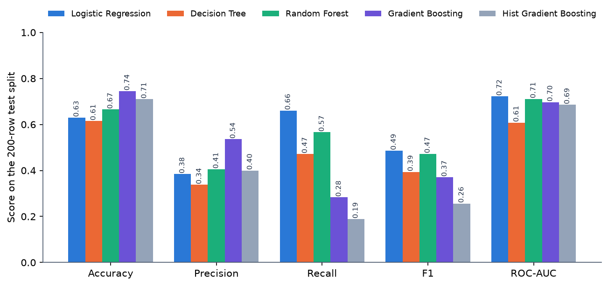
Figure 14: Test-split metrics of the five models (class weights, seed 42)
Three points stand out. First, Gradient Boosting has the highest accuracy (0.7450) and precision (0.5357) but a recall of only 0.2830 (Hist Gradient Boosting is lower still at 0.1887), because boosting in this implementation takes no class weight and therefore favours the majority class; for a retention team that must find churners, its accuracy is misleading. Second, the three required models are close: Logistic Regression and Random Forest have F1 of 0.4861 and 0.4724, and the Decision Tree is lower at 0.3937. Third, ROC-AUC is about 0.72 for the best models, a moderate ability to rank churners above stayers, not a strong one.
Sensitivity to the software environment. The same script under scikit-learn 1.5.0 and pandas 2.2.1 gives identical Logistic Regression results but a different Random Forest on this 200-row split (accuracy 0.7200 against 0.6650; F1 0.4815 against 0.4724). Tree ensembles on 800 training rows are version-sensitive, which is another reason to treat single-split differences between the two best models as noise. The archived output is metrics_sklearn1.5.0.json.

8.4 Confusion Matrices and Curves
Table 27: Confusion matrices on the test split (200 rows: 147 retained, 53 churners)
Model | True negative | False positive | False negative | True positive
Logistic Regression | 91 | 56 | 18 | 35
Decision Tree | 98 | 49 | 28 | 25
Random Forest | 103 | 44 | 23 | 30
Gradient Boosting | 134 | 13 | 38 | 15
Hist Gradient Boosting | 132 | 15 | 43 | 10

Logistic Regression finds 35 of the 53 churners but flags 56 retained customers by mistake; Random Forest finds 30 and flags 44; Gradient Boosting finds only 15 and flags 13. The choice between them is a trade-off between wasted offers and lost customers, which the threshold analysis in Section 8.8 makes explicit.
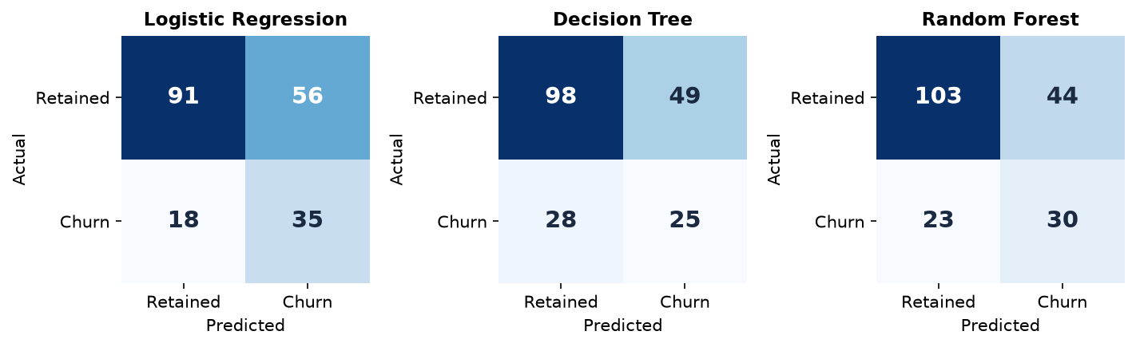
Figure 15: Confusion matrices of the three required models
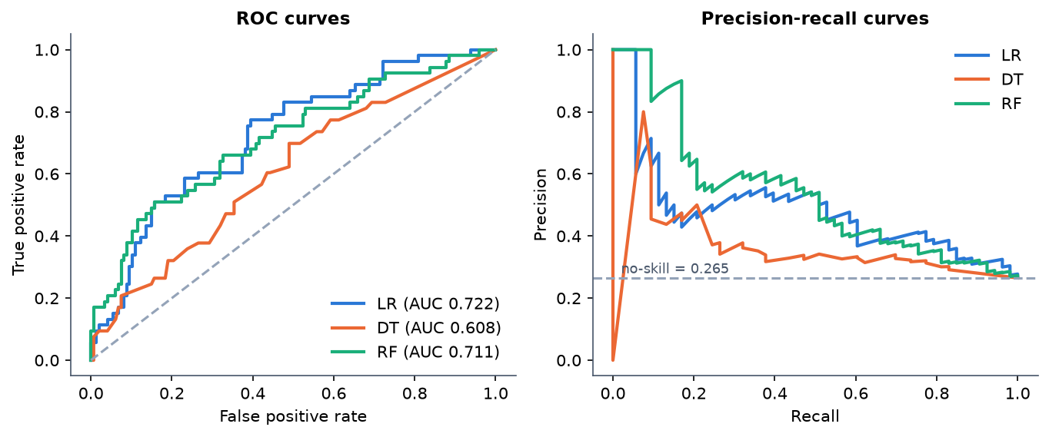
Figure 16: ROC and precision-recall curves of the three required models on the test split

8.5 Stability of the Results
A 200-row test set with 53 churners is small. To see how much the numbers move, the three required models were re-evaluated by stratified 5-fold cross-validation (200 held-out rows per fold) and on five random 80/20 splits.
Table 28: Stratified 5-fold cross-validation, class weights (mean ± sd over folds)
Model | Accuracy | Precision | Recall | F1-score | ROC-AUC
Logistic Regression | 0.6480 ± 0.0396 | 0.3953 ± 0.0455 | 0.6246 ± 0.0844 | 0.4833 ± 0.0547 | 0.6945 ± 0.0463
Decision Tree | 0.6070 ± 0.0236 | 0.3494 ± 0.0254 | 0.5643 ± 0.0390 | 0.4313 ± 0.0281 | 0.6226 ± 0.0201
Random Forest | 0.6700 ± 0.0252 | 0.4070 ± 0.0341 | 0.5452 ± 0.0977 | 0.4634 ± 0.0506 | 0.6974 ± 0.0417

Table 29: Five random 80/20 splits, seeds 0-4, class weights (mean ± sd)
Model | Accuracy | Precision | Recall | F1-score | ROC-AUC
Logistic Regression | 0.6650 ± 0.0200 | 0.4155 ± 0.0248 | 0.6566 ± 0.1011 | 0.5075 ± 0.0443 | 0.7231 ± 0.0344
Decision Tree | 0.6040 ± 0.0258 | 0.3593 ± 0.0260 | 0.6302 ± 0.0560 | 0.4573 ± 0.0332 | 0.6484 ± 0.0396
Random Forest | 0.7040 ± 0.0284 | 0.4543 ± 0.0356 | 0.5509 ± 0.0524 | 0.4965 ± 0.0325 | 0.7102 ± 0.0171

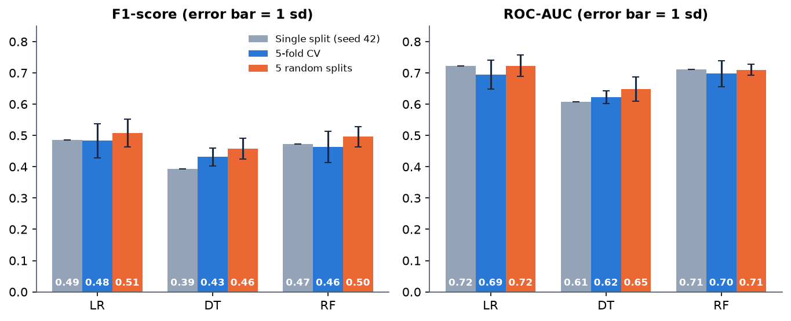
Figure 17: F1-score and ROC-AUC on the single split, in cross-validation and on five splits (error bars: one standard deviation)
Logistic Regression and Random Forest are within one standard deviation of each other on F1 and ROC-AUC in both protocols, so the data do not support calling either one better. Logistic Regression has the higher recall and Random Forest the higher precision and accuracy. The Decision Tree is the weakest on accuracy, precision, F1 and ROC-AUC (its recall is not the lowest). The spread on F1 is 0.03-0.05 and on recall 0.04-0.10, so differences of a few points on a single split should not be over-read.

8.6 Effect of Imbalance Handling
Table 30: Logistic Regression and Random Forest under the three strategies (single split)
Model | Strategy | Accuracy | Precision | Recall | F1-score | ROC-AUC
Logistic Regression | None | 0.7450 | 0.5556 | 0.1887 | 0.2817 | 0.7202
Logistic Regression | Class weights | 0.6300 | 0.3846 | 0.6604 | 0.4861 | 0.7224
Logistic Regression | SMOTE | 0.6850 | 0.4375 | 0.6604 | 0.5263 | 0.7283
Random Forest | None | 0.7550 | 0.8333 | 0.0943 | 0.1695 | 0.7176
Random Forest | Class weights | 0.6650 | 0.4054 | 0.5660 | 0.4724 | 0.7111
Random Forest | SMOTE | 0.7100 | 0.4359 | 0.3208 | 0.3696 | 0.7032

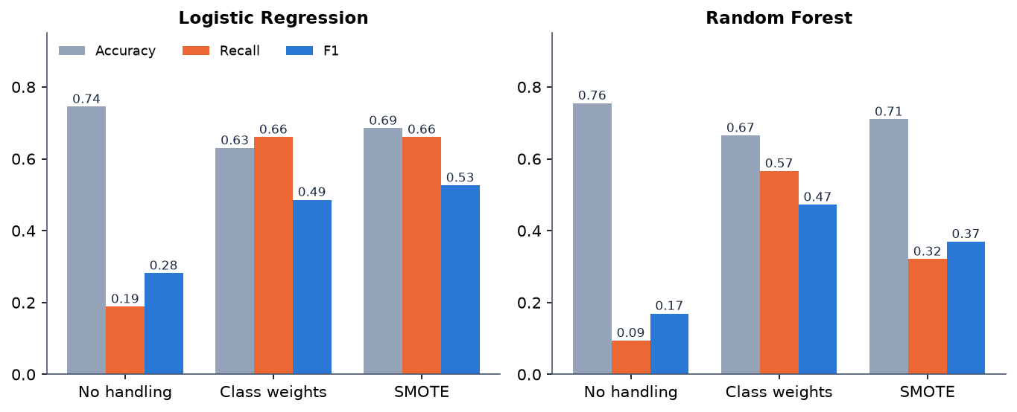
Figure 18: Accuracy, recall and F1 of Logistic Regression and Random Forest under the three imbalance strategies
Without any handling the models look good on accuracy (0.7450 for Logistic Regression, 0.7550 for Random Forest) but recall collapses to 0.1887 and 0.0943: they miss most churners. Class weights and SMOTE restore recall at the cost of precision. SMOTE gave the best single-split F1 for Logistic Regression (0.5263) but was tested on one split only, so it is not claimed to be better than class weights. This is the reason the application selects on F1 and not on accuracy.

8.7 Drivers of Churn
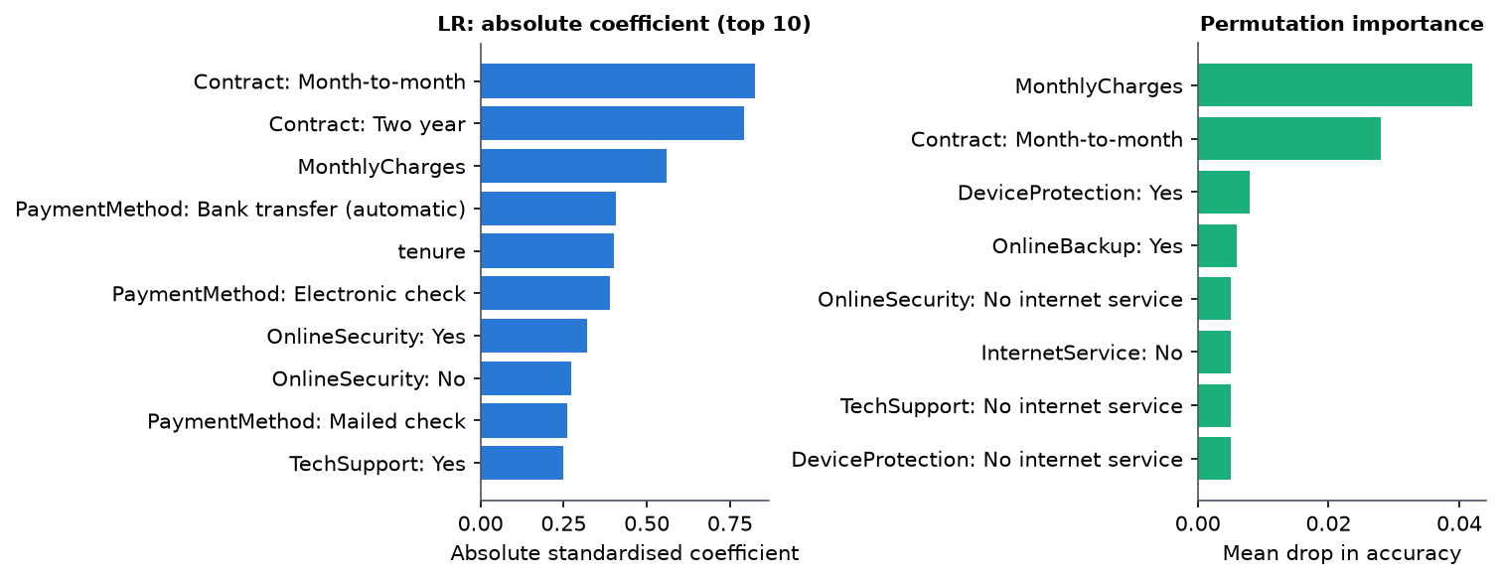
Figure 19: Largest Logistic Regression coefficients and permutation importance
For Logistic Regression the largest absolute coefficients belong to contract type (Month-to-month 0.825 and Two year 0.791), monthly charges (0.558), automatic bank-transfer payment (0.408), tenure (0.400) and electronic-check payment (0.388). Permutation importance, which measures the fall in accuracy when one feature is shuffled, is led by MonthlyCharges (0.042) and Contract: Month-to-month (0.028); the others are 0.01 or less, which is noise-level on 200 rows. The generator used contract type, electronic check, tenure, support and security add-ons, fibre optic and monthly charges as drivers, so the model recovers the main ones. This confirms the pipeline works; it is not evidence about real customers.

8.8 Threshold, Calibration and Targeting
Decision threshold. The batch table calls a customer a predicted churner at 50% or more. Moving the threshold trades precision for recall:
Table 31: Logistic Regression: effect of the decision threshold on the test split
Threshold | Flagged of 200 | Precision | Recall | F1
0.30 | 157 | 0.325 | 0.962 | 0.486
0.40 | 126 | 0.357 | 0.849 | 0.503
0.50 | 91 | 0.385 | 0.660 | 0.486
0.60 | 53 | 0.509 | 0.509 | 0.509
0.70 | 22 | 0.455 | 0.189 | 0.267

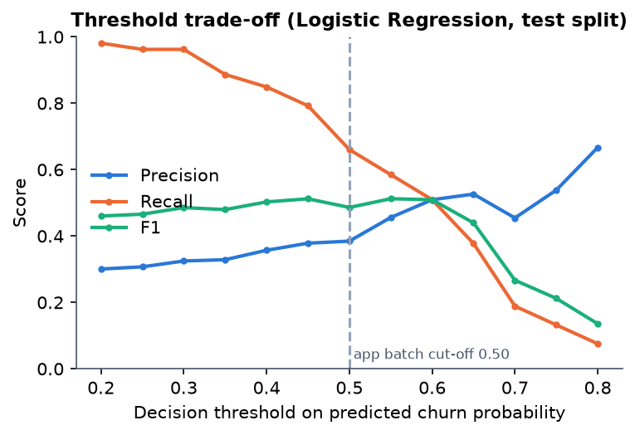
Figure 20: Precision, recall and F1 against the decision threshold (Logistic Regression)
F1 is almost flat between 0.40 and 0.60 (0.503 to 0.512), so the 50% cut-off is a reasonable default; a retention team with cheap offers would lower it (at 0.30 recall is 0.962 but only 32% of those flagged are churners), and a team with costly offers would raise it.
Calibration. The predicted probabilities are not calibrated. The mean predicted probability on the test split is 0.461 against an observed churn rate of 0.265, every reliability bin over-predicts, and the Brier score is 0.213, no better than the 0.195 of a constant predictor that always outputs the base rate. Class weights are the likely cause of the over-prediction: they shift the scores upward on purpose. The scores are therefore a ranking, and the risk bands should not be read as chances of leaving. Recalibration (for example Platt scaling or isotonic regression) is listed as future work.
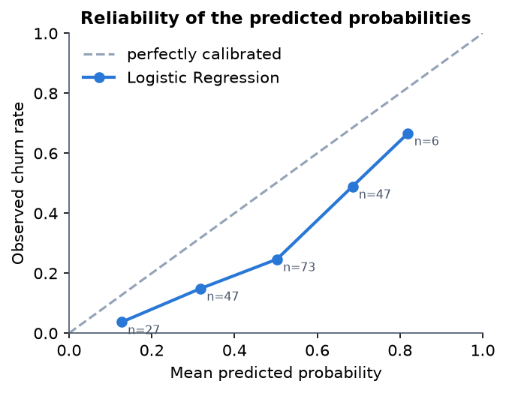
Figure 21: Reliability of the predicted probabilities (Logistic Regression, test split)
Targeting value. If the retention team contacts customers in order of predicted risk, the top 10% (20 customers) contain 9 churners (precision 0.45, lift 1.70); the top 20% (40 customers) contain 21 of the 53 churners (39.6%, precision 0.525, lift 1.98); the top 30% contain 28 (52.8%); and the top 50% contain 41 (77.4%). The lift of 1.5 to 2 over random contact is a moderate gain, and with 20 to 60 contacts the counts are small.
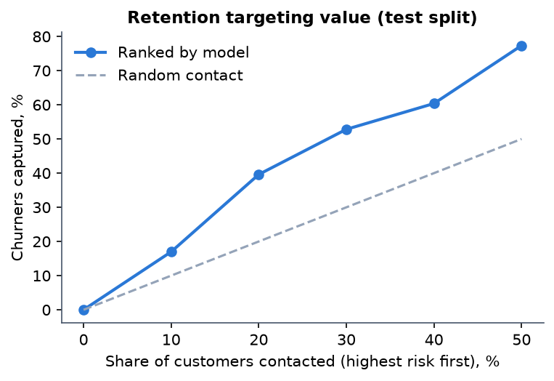
Figure 22: Churners captured when contacting the highest-scored customers first (test split)

8.9 Comparison with the Base Paper
The comparison is for context only. The base paper [1] and this project use different data, splits, models and goals, and the metrics are not comparable: the paper's real 7,043-row data with a 2,113-row test set against this project's 1,000 synthetic rows with a 200-row test set.
Table 32: Base paper compared with this project
Aspect | Base paper (Oprea and Bara, 2026) | This project
Data | Real Telco churn, 7,043 rows, 21 columns, 26.5% churn | Synthetic, 1,000 rows, same schema, 26.4% churn
Split | 70/30, test 2,113 rows | 80/20 stratified, test 200 rows (53 churners)
Classifiers | LR, SVC, RF, balanced RF, CatBoost, XGBoost, LightGBM | LR, DT, RF (required); GB, HGB (optional); scikit-learn only
Imbalance | class weights, scale_pos_weight | class weights, SMOTE (train only), none
Objective | Recall | F1 by default; any of five metrics selectable
Reported metrics | Accuracy 0.6990-0.7932; recall 0.4112-0.9077; ROC-AUC 0.83-0.86 for CatBoost, XGBoost, LightGBM | Accuracy 0.6150-0.7450; recall 0.1887-0.6604; ROC-AUC 0.6081-0.7224 (single split)
Explainability | SHAP, LIME and a unified perturbation explainer; Spearman 0.8125 with SHAP; SHAP 289.4 s, LIME 35.1 s, PBE 18.5 s | Built-in and permutation importance, coefficient-times-value local explanation; SHAP path present but not exercised; no LIME, no unified perturbation explainer
Beyond the paper | Framework only | Risk bands, Customer 360, what-if, retention rules, batch scoring, drift check, web interface
Drivers found | Month-to-month contracts, high monthly charges, tenure below 20 months | The same three, on data generated with those relationships

The project's metrics are lower than the paper's boosted models, as expected: it uses simpler models, no hyper-parameter search, a much smaller training set and synthetic data in which churn contains deliberate noise. No claim is made that the project matches or beats the paper; its contribution is the application around a churn model, not a better churn model.

8.10 Risk Segmentation of the Customer Base
Table 33: Customers per risk band (1,000 customers, saved Logistic Regression model, thresholds 30 / 60 / 80)
Band | Customers | Share
Low Risk | 253 | 25.3%
Medium Risk | 481 | 48.1%
High Risk | 213 | 21.3%
Critical Risk | 53 | 5.3%

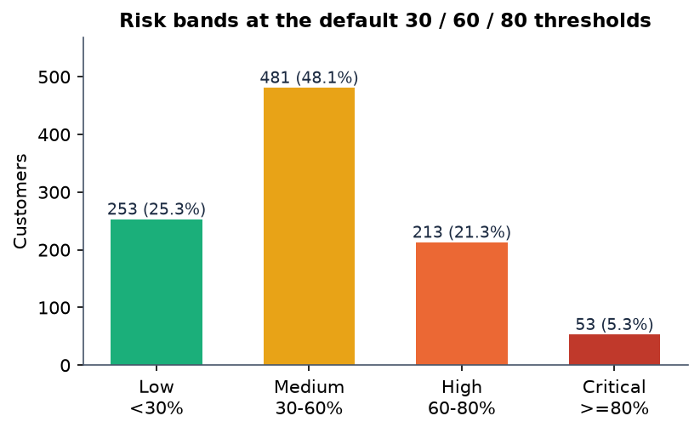
Figure 23: Customers per risk band at the default thresholds
The mean score is 45.89%. These customers include the training rows, so the table shows the portfolio view that the dashboard presents and not generalisation. Because the scores are inflated by class weighting, the 266 customers in the High and Critical bands (26.6%) are the ones the rules treat as candidates for action; their share happens to be close to the 26.4% real churn rate, which should not be read as a calibration.

8.11 Performance
Table 34: Measured response times
Measurement | Result
Train the five models, class weights (wall time, incl. evaluation) | 2.96 s; Random Forest alone 1.117 s
Score one customer (preprocess + predict), 200 runs | median 19.07 ms, 95th percentile 33.66 ms (pandas 3 / scikit-learn 1.9); 2.85 ms median under pandas 2 / scikit-learn 1.5
Score all 1,000 customers | 35.4 ms
API median over 127.0.0.1: dashboard / Customer 360 / local explanation / what-if / retention / EDA | 93.8 / 79.7 / 68.3 / 64.6 / 77.2 / 84.8 ms
API: global explanation / evaluation / health | 11.6 / 53.5 / 37.8 ms
API: batch predict 25 rows (no drivers) | median 70.3 ms
API one-off: load sample / prepare / train 3 models / save model | 181.6 / 38.0 / 1515.3 / 89.1 ms

Every call is well under a second. Two measurement notes: single-customer scoring is about 6.7 times slower under the newer pandas and scikit-learn (19 ms against 2.9 ms), and a request through the hostname localhost carries an extra 2.04 s on this Windows machine because of IPv6 name resolution, which is why the figures were taken against 127.0.0.1, the address the web interface proxy uses. Timings vary between runs and depend on whether other programs are using the machine.

8.12 Output Screens
The screenshots were captured from the running application at 1440 x 900 with the sample data loaded, three models trained and the Logistic Regression model saved. They show real values, not mock-ups.
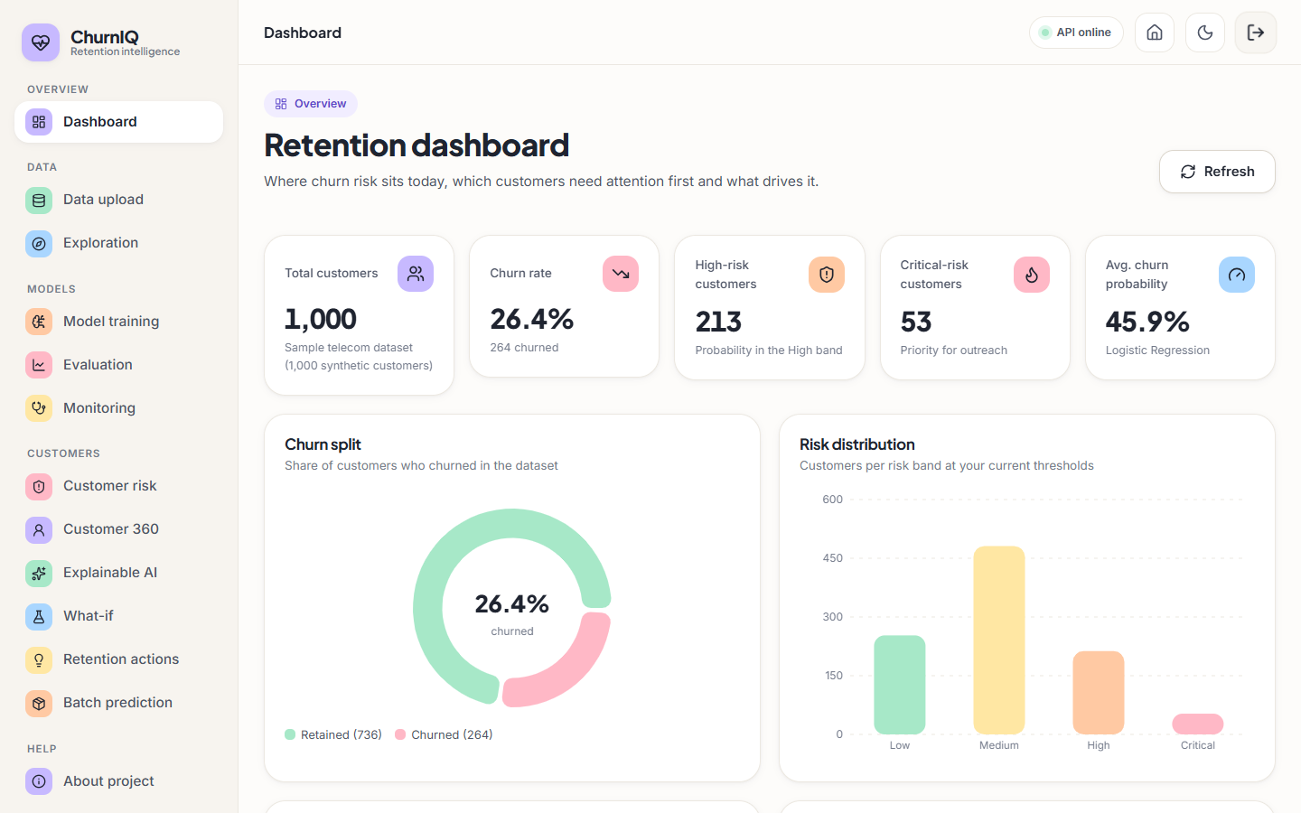
Figure 24: Retention dashboard: portfolio KPIs, churn split and risk distribution
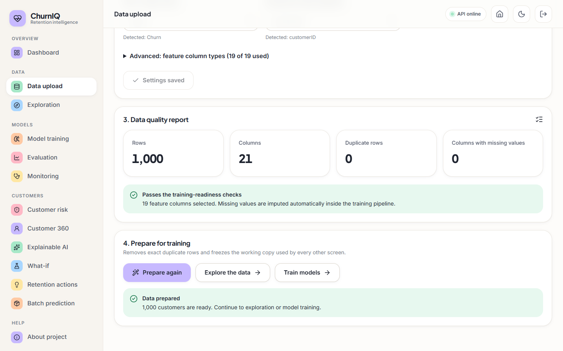
Figure 25: Data upload page: data quality report and preparation of the working copy
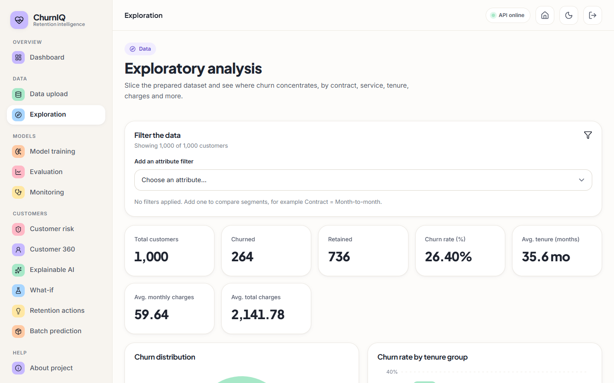
Figure 26: Exploration page: churn rate by customer attribute
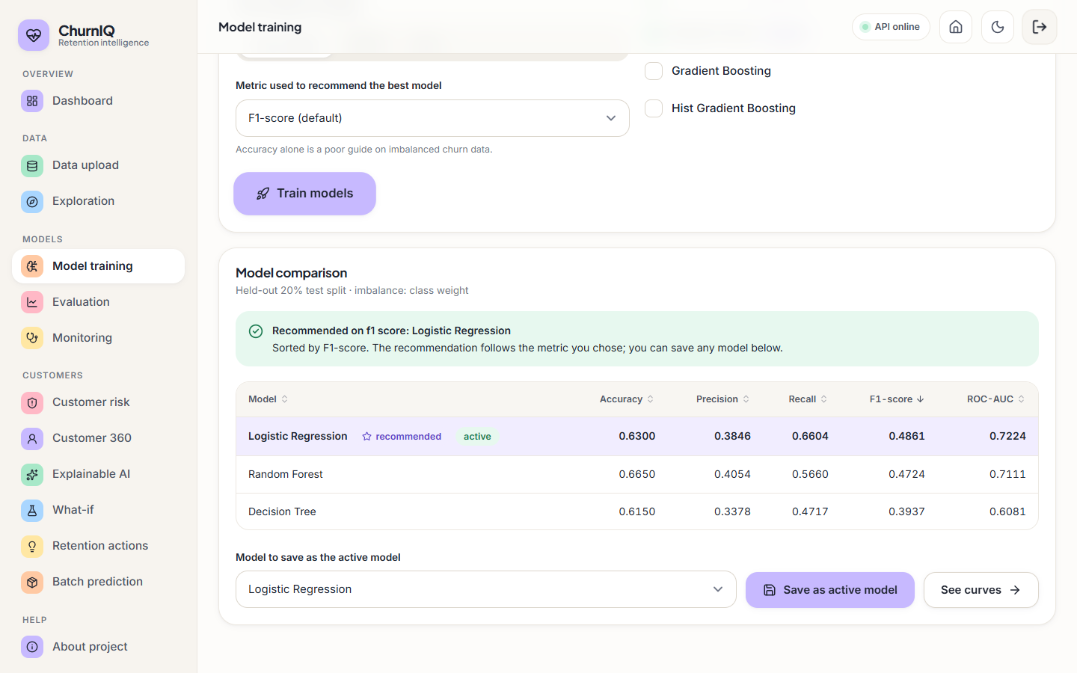
Figure 27: Model training page: metric choice, model comparison and saving the active model
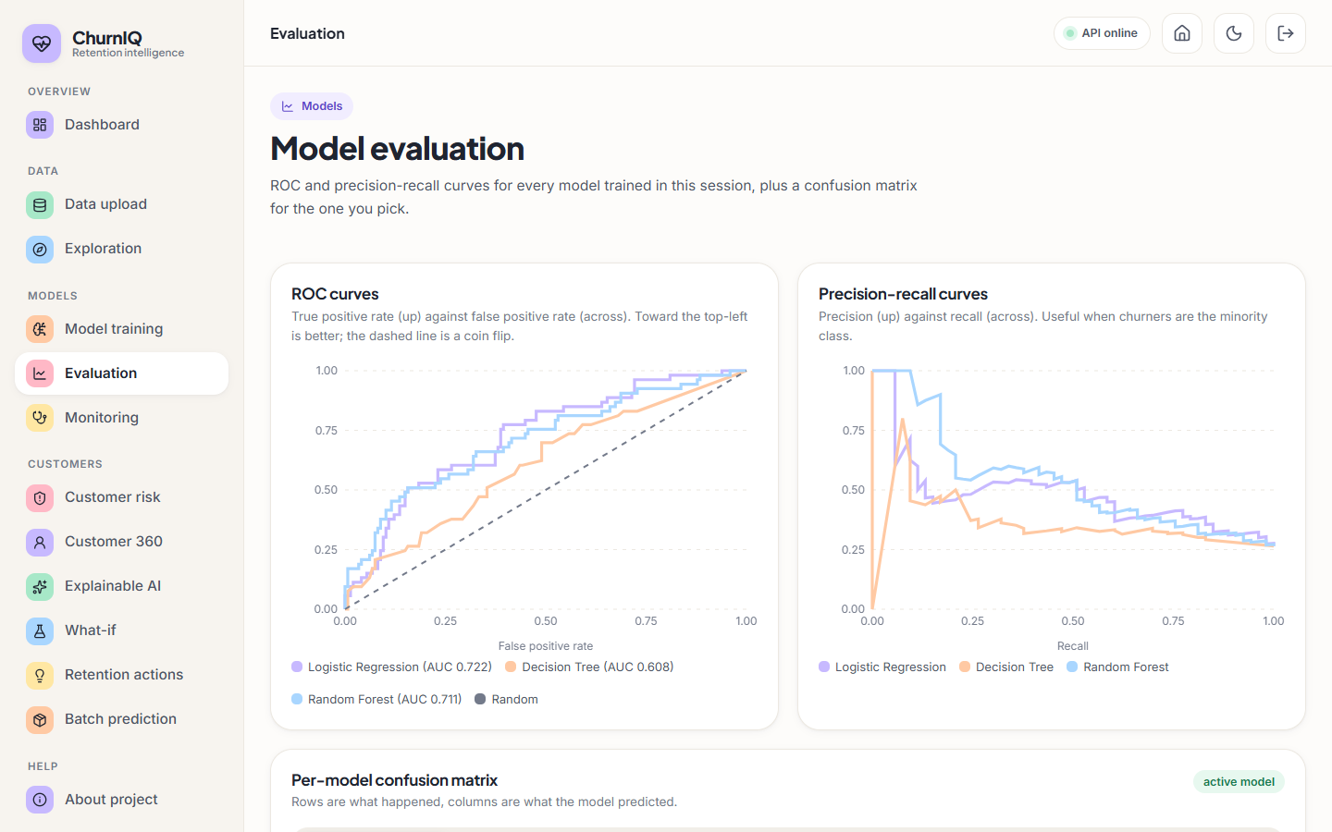
Figure 28: Model evaluation page: ROC and precision-recall curves of the models trained in the session
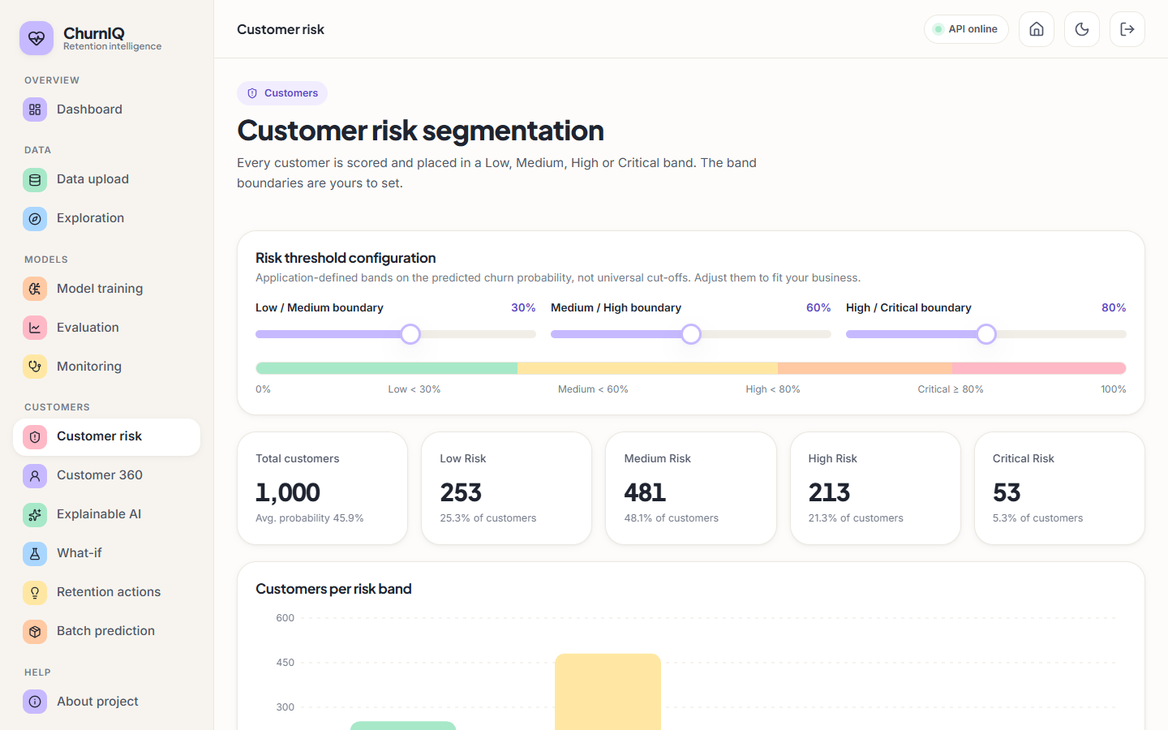
Figure 29: Customer risk segmentation: editable thresholds and customers per band (default 30 / 60 / 80)
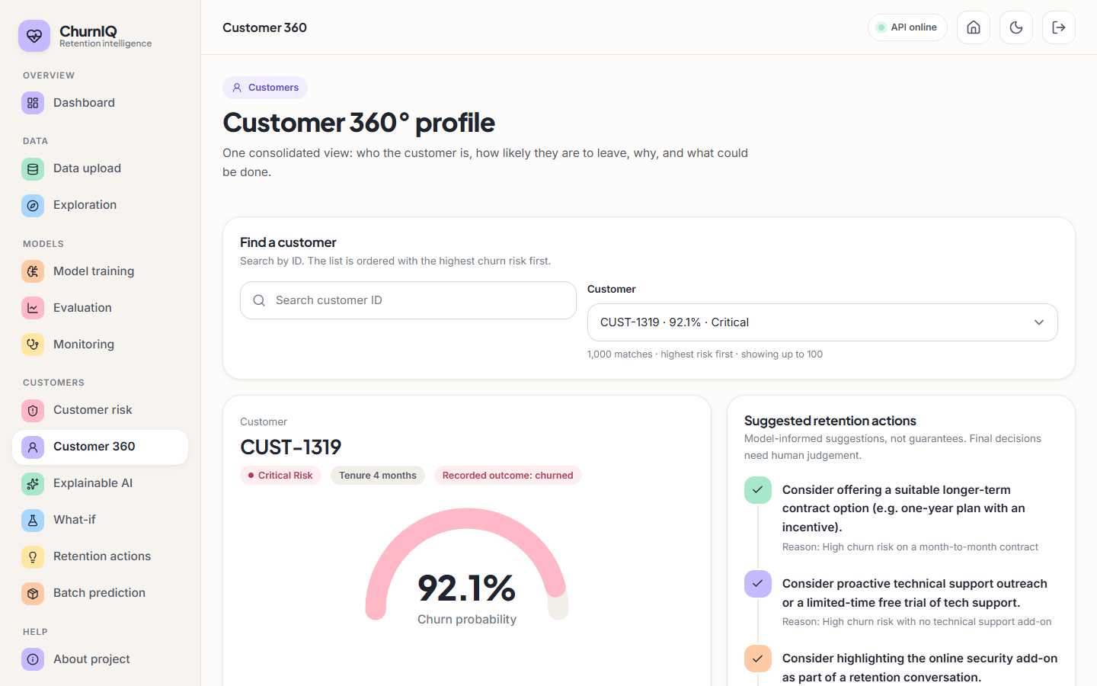
Figure 30: Customer 360: profile, score, band, drivers and retention actions
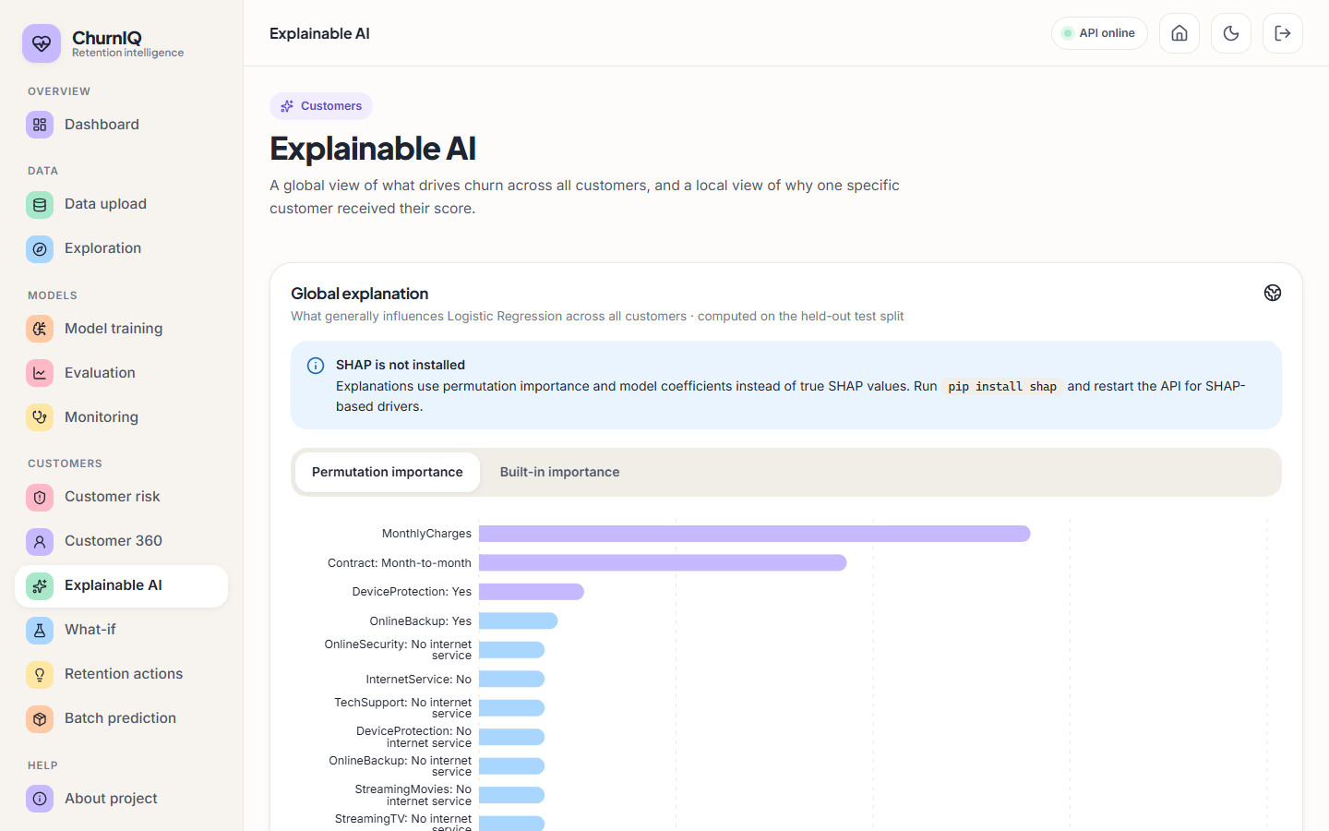
Figure 31: Explainable AI page: permutation importance, with the notice that SHAP is not installed
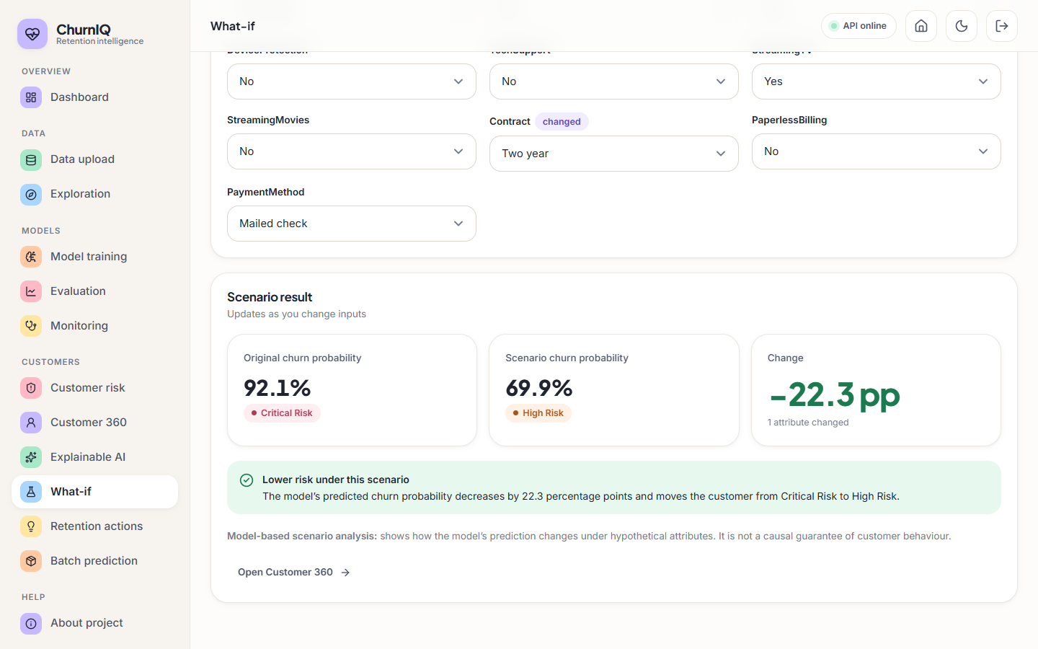
Figure 32: What-if page: original and scenario score for an edited customer
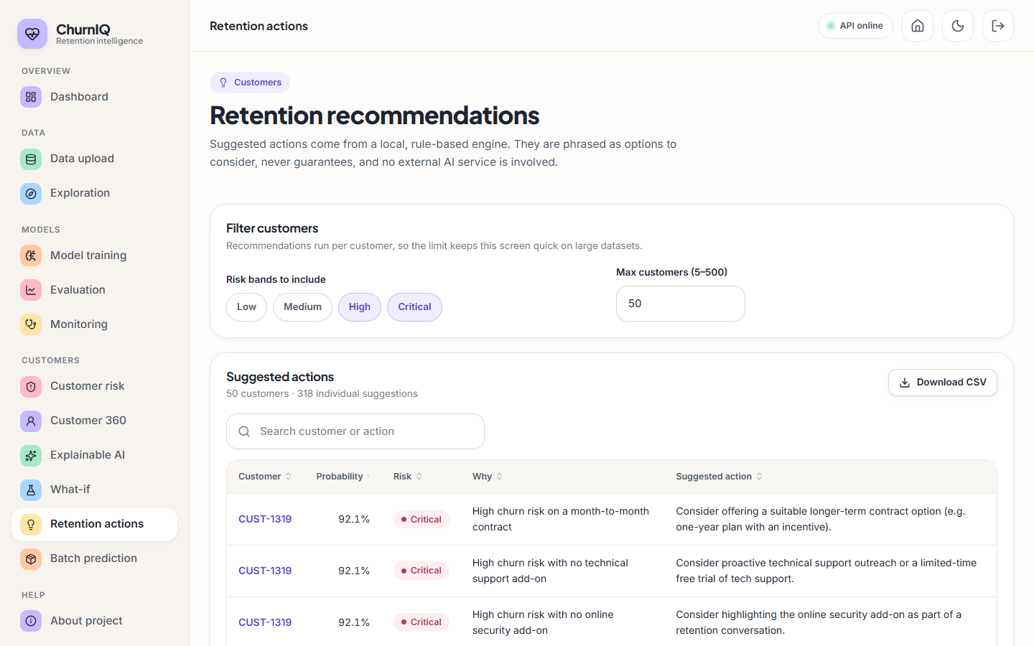
Figure 33: Retention page: rule-based actions for High and Critical customers
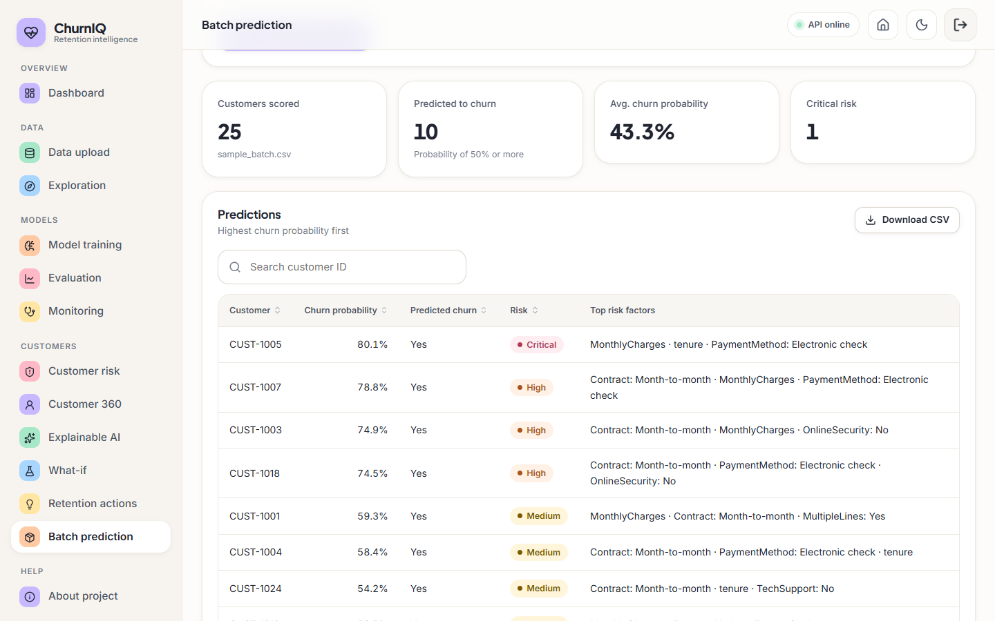
Figure 34: Batch prediction page: scoring a CSV with risk bands and top factors
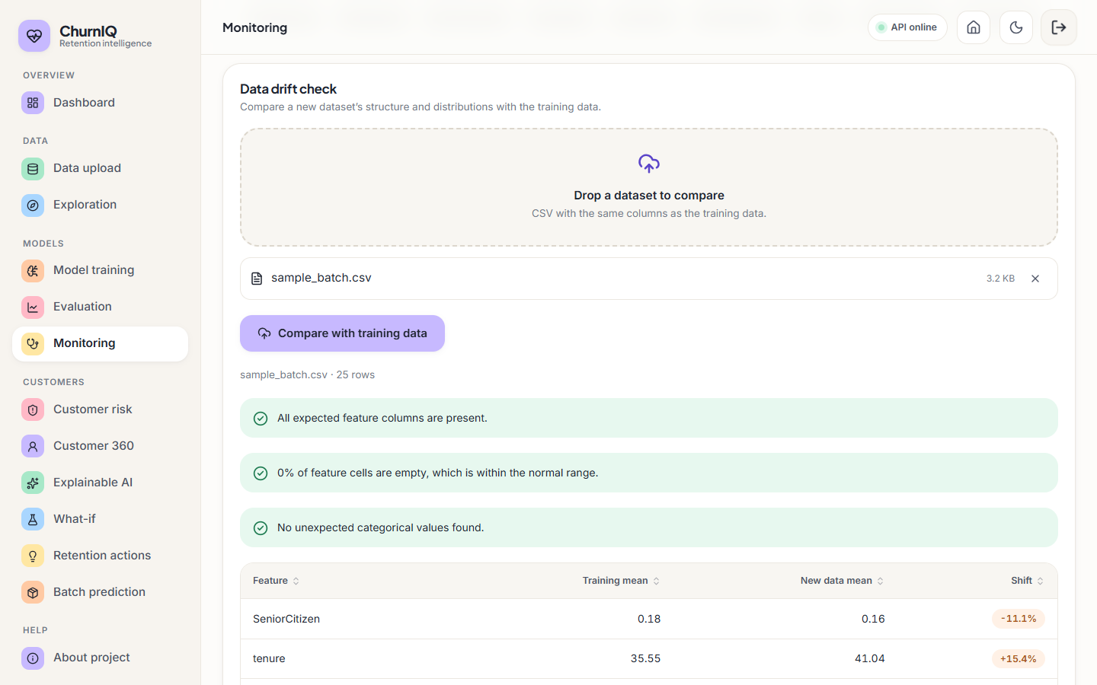
Figure 35: Monitoring page: active model details and the drift check

8.13 Discussion and Threats to Validity
• What the results support. The pipeline works end to end, recovers the contract, charge and tenure effects built into the synthetic data, ranks customers moderately well (ROC-AUC about 0.72, lift about 2 in the top 20%), and shows why accuracy is a poor guide on imbalanced data.
• What they do not support. Any claim about accuracy on real customers; a ranking of Logistic Regression against Random Forest; calibrated probabilities; the business value of the retention rules.
• Data validity. The data are synthetic and the churn label is generated from the same features the model sees, so the relationships are cleaner than in real data.
• Statistical validity. The test set has 53 churners; standard deviations of 0.03-0.10 on several metrics mean that differences of a few points are not reliable.
• Environment validity. Tree-ensemble scores differ between scikit-learn versions on this small split.
• Explanation validity. The explanations come from coefficients and permutation importance. They describe the model, not the customers' reasons, and they were not compared with SHAP.

CHAPTER 9: CONCLUSION

9.1 Summary of the Work
This project set out to move customer-churn work from a table of classifier metrics to a tool a retention team can use. It built a complete pipeline and application: a data loader that profiles and validates a customer table, a preprocessing pipeline fitted on the training split only, three required and two optional classifiers with class-weight or SMOTE imbalance handling, an evaluation module with five metrics and the usual curves, a risk-banding scheme with editable thresholds, global and per-customer explanations, a what-if analysis, a transparent rule engine that turns drivers into retention suggestions, batch scoring and a drift check. These are delivered through two interfaces on one core: the original Streamlit application and the ChurnIQ web interface served by a FastAPI layer.
On the synthetic sample (1,000 customers, 26.4% churn) the best model by F1 is Logistic Regression: accuracy 0.630, precision 0.385, recall 0.660, F1 0.486 and ROC-AUC 0.722 on a 200-row test split. Cross-validation and repeated splits show that Logistic Regression and Random Forest cannot be separated reliably (F1 0.483 ± 0.055 and 0.463 ± 0.051 in 5-fold cross-validation). Ranking customers by predicted risk and contacting the top 20% reached 39.6% of the churners, a lift of about 2 over random contact.

9.2 Objectives Revisited
Table 35: Outcome against the six objectives
No. | Objective | Outcome | Evidence
1 | Acquire a dataset and explore churn behaviour | Met, with a caveat | A synthetic 1,000-customer data set with the Telco schema is generated (no real operator data); the Explore page and Section 8.2 show churn by contract, tenure, service and payment
2 | Clean, encode and address class imbalance | Met | Duplicate removal, imputation, scaling, one-hot encoding; class weights and SMOTE; recall measured with and without handling (0.1887 against 0.6604 for Logistic Regression)
3 | Train and compare Logistic Regression, Decision Tree and Random Forest | Met | All three trained and compared (plus Gradient Boosting and Histogram Gradient Boosting); Logistic Regression recommended on F1
4 | Evaluate with accuracy, precision, recall, F1 and ROC-AUC | Met | All five metrics, confusion matrices, ROC and precision-recall curves, plus cross-validation and repeated splits
5 | Identify the features that drive churn | Met | Coefficients and permutation importance: contract type, monthly charges, tenure and payment method lead. SHAP not exercised
6 | Present at-risk customers and drivers through a dashboard | Met | Dashboard, risk bands, Customer 360, what-if, retention actions, batch scoring and monitoring pages

9.3 Limitations
The conclusions are limited in the following ways, which are discussed in full in the Scope and Limitations document:
• The data are synthetic. The metrics describe the pipeline on generated data and say nothing about accuracy on a real operator's customers.
• The test split has 200 rows and 53 churners. Cross-validation and repeated splits show spreads of 0.03 to 0.10 on several metrics, and a Random Forest result changes with the scikit-learn version.
• The ranking ability is moderate (ROC-AUC about 0.72, F1 about 0.46-0.51) and the probabilities are not calibrated (Brier score 0.213 against 0.195 for a constant predictor).
• SHAP was not installed, so no SHAP result is reported; the explanations are coefficient-times-value and permutation importance.
• The retention rules are heuristics written by the team. Their effect on real churn was not measured.
• There is no database, no multi-user support and no real authentication; the login is a demonstration.
• No user-acceptance study, load test or non-Chrome browser test was carried out.

9.4 Concluding Remarks
The project shows that an end-to-end churn workflow can be built from open-source parts, run on a desktop in seconds, and made inspectable at every step: the data are profiled, the model is chosen on a metric that is not fooled by imbalance, each score carries its drivers, and each suggestion carries its rule. It follows the motivation of the base paper [1], that churn predictions are most useful when they can be explained, and supplies the application layer the paper leaves open. Its numerical results are a demonstration on synthetic data; the next step, described in Chapter 10, is to repeat the evaluation on real customer records before any retention decision depends on it.

CHAPTER 10: FUTURE SCOPE
The work leaves several directions open. They are ordered by how much they would change the value of the system.
1. Validate on real data. Repeat the experiments on real operator data or at least on the real public Telco file (7,043 rows), which the loader already supports after the pandas-3 fix. This would give metrics that can be compared with the base paper under a stated protocol, a much larger test set, and an honest answer to whether the synthetic-data conclusions hold.
2. Calibrate the probabilities. Apply Platt scaling or isotonic regression on a validation split so that a score of 60 can be read as a chance of about 60%, and report reliability curves and the Brier score as part of the Evaluation page.
3. Add SHAP and the base paper's explainers. Install and test the SHAP code path that already exists, compare it with the permutation and coefficient explanations, and implement LIME and a unified perturbation explainer in the manner of the base paper to compare fidelity, consistency and runtime on the same models.
4. Stronger models and tuning. Add XGBoost, LightGBM and CatBoost, tune hyper-parameters by cross-validation, and keep Logistic Regression as the interpretable baseline. Evaluate on cross-validation first, given the noise of a single split.
5. Cost-sensitive decisions. Let the analyst enter the cost of an offer and the value of a retained customer, choose the decision threshold that maximises expected profit, and show the expected return of contacting the top k%.
6. Measure the retention rules. Run a controlled campaign (offer against no offer) on a sample of high-risk customers to estimate uplift, and refine or retire the rules according to measured effect.
7. Time and behaviour. Use usage, complaint and billing histories over time (survival analysis or sequence features) so that churn can be predicted months ahead and not only from a snapshot.
8. Production foundations. Replace the in-memory state by a database, add real accounts with roles and an audit log, store models with versions, and add scheduled batch scoring and statistical drift tests (population stability index, Kolmogorov-Smirnov).
9. Integration. Expose scores to a CRM through the API, and containerise the services for deployment.
The first three are the most important: they address the main weakness of this report (synthetic data), the main weakness of the scores (calibration) and the main gap against the base paper (explanation methods).

REFERENCES
[1] S.-V. Oprea and A. Bara, "Explaining customer churn through unified perturbation-based XAI soft computing," IEEE Access, vol. 14, pp. 24460-24478, 2026, doi: 10.1109/ACCESS.2026.3663648.
[2] A. Sikri, R. Jameel, S. M. Idrees and H. Kaur, "Enhancing customer retention in telecom industry with machine learning driven churn prediction," Sci. Rep., vol. 14, no. 1, 2024, doi: 10.1038/s41598-024-63750-0.
[3] A. El Attar and M. El-Hajj, "Explainable AI-driven customer churn prediction: a multi-model ensemble approach with SHAP-based feature analysis," Front. Artif. Intell., vol. 9, Feb. 2026, doi: 10.3389/frai.2026.1748799.
[4] H. A. Rasool, K. K. Aljawaheri and A. A. M. Karram, "Explainable customer churn prediction in telecom using ensemble learning and SHAP analysis," Math. Model. Eng. Probl., pp. 4373-4386, Dec. 2025, doi: 10.18280/mmep.121226.
[5] A. K. Ahmad, A. Jafar and K. Aljoumaa, "Customer churn prediction in telecom using machine learning in big data platform," J. Big Data, vol. 6, no. 1, Mar. 2019, doi: 10.1186/s40537-019-0191-6.
[6] T. Vafeiadis, K. I. Diamantaras, G. Sarigiannidis and K. Ch. Chatzisavvas, "A comparison of machine learning techniques for customer churn prediction," Simul. Model. Pract. Theory, vol. 55, 2015.
[7] S. M. Lundberg and S.-I. Lee, "A unified approach to interpreting model predictions," in Proc. Adv. Neural Inf. Process. Syst. (NeurIPS), vol. 30, 2017.
[8] M. T. Ribeiro, S. Singh and C. Guestrin, "'Why should I trust you?': Explaining the predictions of any classifier," in Proc. 22nd ACM SIGKDD Int. Conf. Knowl. Discovery Data Mining, 2016, pp. 1135-1144, doi: 10.1145/2939672.2939778.
[9] D. Slack, S. Hilgard, E. Jia, S. Singh and H. Lakkaraju, "Fooling LIME and SHAP: Adversarial attacks on post hoc explanation methods," in Proc. AAAI/ACM Conf. AI, Ethics, Soc., 2020, doi: 10.1145/3375627.3375830.
[10] S. M. Lundberg et al., "From local explanations to global understanding with explainable AI for trees," Nature Mach. Intell., vol. 2, no. 1, pp. 56-67, Jan. 2020, doi: 10.1038/s42256-019-0138-9.
[11] N. V. Chawla, K. W. Bowyer, L. O. Hall and W. P. Kegelmeyer, "SMOTE: Synthetic minority over-sampling technique," J. Artif. Intell. Res., vol. 16, pp. 321-357, 2002, doi: 10.1613/jair.953.
[12] H. He and E. A. Garcia, "Learning from imbalanced data," IEEE Trans. Knowl. Data Eng., vol. 21, no. 9, pp. 1263-1284, Sep. 2009.
[13] L. Breiman, "Random forests," Mach. Learn., vol. 45, no. 1, pp. 5-32, Oct. 2001, doi: 10.1023/A:1010933404324.
[14] F. Pedregosa et al., "Scikit-learn: Machine learning in Python," J. Mach. Learn. Res., vol. 12, pp. 2825-2830, 2011.
[15] C. K. Leung, A. G. M. Pazdor and J. Souza, "Explainable artificial intelligence for data science on customer churn," in Proc. IEEE 8th Int. Conf. Data Sci. Adv. Anal. (DSAA), Oct. 2021, pp. 1-10, doi: 10.1109/DSAA53316.2021.9564166.
[16] J. Mohajon and A. S. Mohammad Arif, "Churn prediction with explainability for the customers of telecom industry," in Proc. Int. Conf. Inf. Commun. Technol. Sustain. Develop. (ICICT4SD), Sep. 2023, pp. 179-183, doi: 10.1109/ICICT4SD59951.2023.10303395.
[17] D. Y. C. Wang, L. A. Jordanger and J. C.-W. Lin, "Explainability of leverage points exploration for customer churn prediction," in Proc. IEEE Int. Conf. Big Data (BigData), Dec. 2023, pp. 5997-6004, doi: 10.1109/BigData59044.2023.10386857.
[18] M. Szelag and R. Slowinski, "Explaining and predicting customer churn by monotonic rules induced from ordinal data," Eur. J. Oper. Res., vol. 317, no. 2, pp. 414-424, Sep. 2024, doi: 10.1016/j.ejor.2023.09.028.
[19] IBM, "Telco customer churn," sample data set (7,043 customers, 21 columns), distributed through Kaggle; also used in [1] and [3].
[20] J. H. Friedman, "Greedy function approximation: A gradient boosting machine," Ann. Statist., vol. 29, no. 5, pp. 1189-1232, 2001.
[21] S. Ramirez, "FastAPI documentation," https://fastapi.tiangolo.com (framework used for the API layer).

APPENDIX A: IMPORTANT CODE
The listings are copied from the code base at build time, so they are exactly what runs. Only the most important functions are shown; the complete source is in 8.ProjectCode.

A.1 Preprocessing pipeline (src/preprocessing.py)
def build_preprocessor(numeric_cols: list, categorical_cols: list) -> ColumnTransformer:
numeric_pipeline = Pipeline(steps=[
("imputer", SimpleImputer(strategy="median")),
("scaler", StandardScaler()),
])
categorical_pipeline = Pipeline(steps=[
("imputer", SimpleImputer(strategy="most_frequent")),
("onehot", OneHotEncoder(handle_unknown="ignore")),
])
transformers = []
if numeric_cols:
transformers.append(("num", numeric_pipeline, numeric_cols))
if categorical_cols:
transformers.append(("cat", categorical_pipeline, categorical_cols))

preprocessor = ColumnTransformer(transformers=transformers, remainder="drop")
return preprocessor

def train_test_split_data(X: pd.DataFrame, y: pd.Series, test_size: float = 0.2, random_state: int = 42):
return train_test_split(X, y, test_size=test_size, random_state=random_state, stratify=y)

def apply_smote(X_train_transformed, y_train, random_state: int = 42):
"""Apply SMOTE oversampling to the (already-transformed, numeric)
training data only. Requires imbalanced-learn to be installed."""
from imblearn.over_sampling import SMOTE
smote = SMOTE(random_state=random_state)
X_res, y_res = smote.fit_resample(X_train_transformed, y_train)
return X_res, y_res

A.2 Model training and selection (src/train_models.py)
def train_selected_models(
X_train, y_train, X_test, y_test,
model_names: list,
imbalance_strategy: str = "class_weight", # "none" | "class_weight" | "smote"
):
"""Train each requested model and evaluate it on the held-out test
set. Returns (trained_models: dict, results: dict[name -> metrics]).

imbalance_strategy:
- "class_weight": pass class_weight='balanced' to models that support it
- "smote": oversample the (already-preprocessed, numeric) X_train via SMOTE
- "none": train as-is
"""
trained_models = {}
results = {}

X_tr, y_tr = X_train, y_train
if imbalance_strategy == "smote":
from preprocessing import apply_smote
X_tr, y_tr = apply_smote(X_train, y_train)

class_weight = "balanced" if imbalance_strategy == "class_weight" else None

for name in model_names:
if name not in MODEL_REGISTRY:
continue
builder = MODEL_REGISTRY[name]
# Gradient boosting variants don't accept class_weight
try:
model = builder(class_weight=class_weight)
except TypeError:
model = builder()

model.fit(X_tr, y_tr)
trained_models[name] = model
results[name] = evaluate_model(model, X_test, y_test)

return trained_models, results

def select_best_model(results: dict, metric: str = "f1_score"):
"""Pick the model with the highest value of `metric` (not accuracy
alone, per project requirement -- default is F1)."""
if not results:
return None
best_name = max(results, key=lambda k: results[k][metric])
return best_name

A.3 Evaluation (src/evaluation.py)
def evaluate_model(model, X_test, y_test) -> dict:
y_pred = model.predict(X_test)
if hasattr(model, "predict_proba"):
y_proba = model.predict_proba(X_test)[:, 1]
else:
# fall back for models without predict_proba (shouldn't happen here)
y_proba = y_pred.astype(float)

cm = confusion_matrix(y_test, y_pred)
fpr, tpr, _ = roc_curve(y_test, y_proba)
prec_curve, rec_curve, _ = precision_recall_curve(y_test, y_proba)

return {
"accuracy": accuracy_score(y_test, y_pred),
"precision": precision_score(y_test, y_pred, zero_division=0),
"recall": recall_score(y_test, y_pred, zero_division=0),
"f1_score": f1_score(y_test, y_pred, zero_division=0),
"roc_auc": roc_auc_score(y_test, y_proba) if len(np.unique(y_test)) > 1 else float("nan"),
"confusion_matrix": cm,
"roc_curve": (fpr, tpr),
"pr_curve": (prec_curve, rec_curve),
"y_pred": y_pred,
"y_proba": y_proba,
}

A.4 Risk bands and risk table (src/utils.py, src/risk_segmentation.py)
def assign_risk_category(probability_pct: float, thresholds: dict = None) -> str:
"""Map a churn probability (0-100) to a risk band using configurable
thresholds. `thresholds` has keys 'low', 'medium', 'high' marking the
upper boundary (in %) of the Low, Medium and High bands respectively;
anything above 'high' is Critical.
"""
t = thresholds or DEFAULT_RISK_THRESHOLDS
if probability_pct < t["low"]:
return "Low Risk"
elif probability_pct < t["medium"]:
return "Medium Risk"
elif probability_pct < t["high"]:
return "High Risk"
else:
return "Critical Risk"

def build_risk_table(
df: pd.DataFrame, feature_cols: list, preprocessor, model,
id_col: str | None, thresholds: dict,
display_cols: list | None = None,
) -> pd.DataFrame:
"""Score every row in df and return a risk-annotated table with the
core display columns the UI needs."""
work = df.copy()
proba = score_customers(work[feature_cols], preprocessor, model)

result = pd.DataFrame()
result["customerID"] = work[id_col].values if id_col and id_col in work.columns else np.arange(len(work))
result["churn_probability"] = proba
result["risk_category"] = assign_risk_series(result["churn_probability"], thresholds)

if display_cols:
for c in display_cols:
if c in work.columns:
result[c] = work[c].values

result["risk_category"] = pd.Categorical(result["risk_category"], categories=RISK_ORDER, ordered=True)
return result.sort_values("churn_probability", ascending=False).reset_index(drop=True)

A.5 Scoring and batch prediction (src/prediction.py)
def score_customers(df_features: pd.DataFrame, preprocessor, model) -> np.ndarray:
"""Return churn probability (0-100 scale) for each row of
df_features (raw, untransformed feature columns)."""
X_t = preprocessor.transform(df_features)
proba = model.predict_proba(X_t)[:, 1]
return np.round(proba * 100, 2)

def build_batch_predictions(
new_df: pd.DataFrame, feature_cols: list, preprocessor, model,
id_col: str | None, thresholds: dict, top_driver_lookup=None,
) -> pd.DataFrame:
"""Score a batch of new customers and assemble the standard output
table: customerID, churn_probability, predicted_churn, risk_category,
top_risk_factor_1..3 (if a SHAP explainer / top_driver_lookup fn is
supplied)."""
from utils import assign_risk_series

work = new_df.copy()
proba = score_customers(work[feature_cols], preprocessor, model)
out = pd.DataFrame()
out["customerID"] = work[id_col] if id_col and id_col in work.columns else np.arange(len(work))
out["churn_probability"] = proba
out["predicted_churn"] = np.where(proba >= 50, "Yes", "No")
out["risk_category"] = assign_risk_series(out["churn_probability"], thresholds)

if top_driver_lookup is not None:
drivers = [top_driver_lookup(work.iloc[i]) for i in range(len(work))]
for k in range(3):
out[f"top_risk_factor_{k+1}"] = [d[k] if len(d) > k else "" for d in drivers]
else:
for k in range(3):
out[f"top_risk_factor_{k+1}"] = ""

return out.sort_values("churn_probability", ascending=False).reset_index(drop=True)

A.6 Local explanation (src/explainability.py)
def local_explanation(explainer, model, x_row_transformed, feature_names, top_n: int = 5):
"""Explain a single customer's prediction. Returns
(top_positive: list[(feature, value)], top_negative: list[(feature, value)])
where 'positive' means the feature pushed the prediction TOWARD
churn and 'negative' means it pushed AWAY from churn.

Falls back to a coefficient/importance x value heuristic if SHAP is
unavailable, so the app remains functional either way.
"""
x_row_transformed = np.atleast_2d(x_row_transformed)

if explainer is not None:
try:
shap_vals = _shap_values_for_positive_class(explainer, x_row_transformed)[0]
pairs = list(zip(feature_names, shap_vals))
pairs.sort(key=lambda p: p[1], reverse=True)
top_pos = [(f, v) for f, v in pairs if v > 0][:top_n]
top_neg = [(f, v) for f, v in pairs if v < 0][-top_n:][::-1]
return top_pos, top_neg, "shap"
except Exception:
pass

# ---- Fallback: importance-weighted feature value heuristic ----
if hasattr(model, "feature_importances_"):
base_importance = model.feature_importances_
elif hasattr(model, "coef_"):
base_importance = model.coef_.ravel()
else:
base_importance = np.ones(len(feature_names))

contrib = base_importance * x_row_transformed[0]
pairs = list(zip(feature_names, contrib))
pairs.sort(key=lambda p: p[1], reverse=True)
top_pos = [(f, v) for f, v in pairs if v > 0][:top_n]
top_neg = [(f, v) for f, v in pairs if v < 0][-top_n:][::-1]
return top_pos, top_neg, "approximate"

A.7 Retention rules (src/retention_engine.py)
def generate_recommendations(row: pd.Series, churn_probability: float, risk_category: str) -> list:
"""Return a list of (reason, suggestion) tuples for a single
customer, generated from simple explainable business rules.
"""
recs = []
high_risk = churn_probability >= 60 # High or Critical band by default thresholds

contract = str(_get(row, "Contract", "")).lower()
tech_support = str(_get(row, "TechSupport", "")).lower()
online_security = str(_get(row, "OnlineSecurity", "")).lower()
payment_method = str(_get(row, "PaymentMethod", "")).lower()
monthly_charges = _get(row, "MonthlyCharges")
tenure = _get(row, "tenure")
internet_service = str(_get(row, "InternetService", "")).lower()
streaming_tv = str(_get(row, "StreamingTV", "")).lower()
streaming_movies = str(_get(row, "StreamingMovies", "")).lower()
paperless = str(_get(row, "PaperlessBilling", "")).lower()

if high_risk and "month-to-month" in contract:
recs.append((
"High churn risk on a month-to-month contract",
"Consider offering a suitable longer-term contract option (e.g. one-year plan with an incentive)."
))

if high_risk and tech_support == "no":
recs.append((
"High churn risk with no technical support add-on",
"Consider proactive technical support outreach or a limited-time free trial of tech support."
))

if high_risk and online_security == "no":
recs.append((
"High churn risk with no online security add-on",
"Consider highlighting the online security add-on as part of a retention conversation."
))

if monthly_charges is not None and monthly_charges >= 80 and high_risk:
recs.append((
"High monthly charges combined with high churn risk",
"Review whether the customer's current plan matches their usage, and present available lower-cost alternatives."
))

if payment_method == "electronic check" and high_risk:
recs.append((
"Electronic check payment method with high churn risk",
"Review the customer's payment experience and consider offering a smoother automatic payment option."
))

if tenure is not None and tenure <= 6 and high_risk:
recs.append((
"Very new customer (tenure <= 6 months) at high risk",
"Consider an early-lifecycle onboarding check-in to address any early friction."
))

if internet_service == "fiber optic" and high_risk:
recs.append((
"Fiber optic customer at elevated churn risk",
"Consider a service-quality/satisfaction check-in, since fiber customers in this segment show elevated risk."
))

if streaming_tv == "no" and streaming_movies == "no" and high_risk and internet_service != "no":
recs.append((
"Low engagement with entertainment add-ons",
"Consider a promotional trial of streaming add-ons to increase engagement and perceived value."
))

if paperless == "yes" and high_risk and payment_method == "electronic check":
recs.append((
"Paperless billing with a friction-prone payment method",
"Consider a billing-experience review; combined with electronic check this pattern often co-occurs with higher churn."
))

if risk_category == "Critical Risk":
recs.append((
"Overall churn probability is in the Critical band",
"Consider prioritizing this customer for a direct retention conversation with a case-specific offer."
))

if not recs:
if churn_probability < 30:
recs.append((
"Low churn risk",
"No urgent retention action suggested; continue standard engagement and periodic satisfaction checks."
))
else:
recs.append((
"Moderate churn risk without a single dominant risk factor",
"Consider a general satisfaction check-in and monitor the account for changes in usage or complaints."
))

return recs

A.8 Saving and loading the model (src/persistence.py)
def save_artifacts(model, preprocessor, metadata: dict):
os.makedirs(MODELS_DIR, exist_ok=True)
joblib.dump(model, os.path.join(MODELS_DIR, "model.pkl"))
joblib.dump(preprocessor, os.path.join(MODELS_DIR, "preprocessor.pkl"))
metadata = dict(metadata)
metadata["saved_at"] = dt.datetime.now().isoformat(timespec="seconds")
joblib.dump(metadata, os.path.join(MODELS_DIR, "model_metadata.pkl"))
return metadata

def load_artifacts():
model_path = os.path.join(MODELS_DIR, "model.pkl")
pre_path = os.path.join(MODELS_DIR, "preprocessor.pkl")
meta_path = os.path.join(MODELS_DIR, "model_metadata.pkl")
if not (os.path.exists(model_path) and os.path.exists(pre_path) and os.path.exists(meta_path)):
return None, None, None
model = joblib.load(model_path)
preprocessor = joblib.load(pre_path)
metadata = joblib.load(meta_path)
return model, preprocessor, metadata

A.9 What-if route (backend/main.py)
@private.post("/whatif")
def whatif(body: WhatIfBody):
need_model()
label, row = find_row(body.customer_id)
feats = STATE.model_features
original = float(score_customers(pd.DataFrame([row[feats]]), STATE.preprocessor, STATE.model)[0])
scenario_row = row.copy()
for feat, val in body.changes.items():
if feat not in feats:
raise HTTPException(422, f"“{feat}” is not a feature of the active model.")
scenario_row[feat] = val
try:
scenario = float(score_customers(pd.DataFrame([scenario_row[feats]]), STATE.preprocessor, STATE.model)[0])
except Exception as e:
raise HTTPException(422, f"The model could not score that scenario: {e}")
diff = scenario - original
return ok({
"id": label, "original": original, "scenario": scenario, "change": round(diff, 2),
"original_risk": assign_risk_category(original, STATE.risk_thresholds),
"scenario_risk": assign_risk_category(scenario, STATE.risk_thresholds),
"verdict": "none" if abs(diff) < 0.5 else ("lower" if diff < 0 else "higher"),
})

A.10 Bearer-token authentication (backend/auth.py)
def make_token(email: str) -> str:
body = _b64(json.dumps({"sub": email, "exp": int(time.time()) + config.TOKEN_TTL_SECONDS}).encode())
return f"{body}.{_sign(body)}"

def read_token(token: str) -> dict | None:
try:
body, sig = token.split(".", 1)
if not hmac.compare_digest(sig, _sign(body)):
return None
data = json.loads(_unb64(body))
return data if data.get("exp", 0) > time.time() else None
except Exception:
return None

def require_user(authorization: str | None = Header(default=None)) -> dict:
"""FastAPI dependency: 401 unless a valid bearer token is supplied."""
scheme, _, token = (authorization or "").partition(" ")
data = read_token(token) if scheme.lower() == "bearer" else None
if not data:
raise HTTPException(status_code=401, detail="Your session has expired. Please sign in again.")
return data

APPENDIX B: INSTALLATION AND USER GUIDE

B.1 Prerequisites
• Windows with Python 3.10 or newer and Node.js 18 or newer on the PATH (development used Python 3.11.9 and Node 24.19.0).
• Internet access on the first run only, to download Python and Node packages.
• A modern browser; the interface was checked in Chrome.

B.2 One-command start
From the folder 8.ProjectCode, run run.bat. On the first run it creates the virtual environment .venv, installs backend\requirements.txt, runs npm install in frontend\, starts the API on port 8314 and the web interface on port 5314 and opens the browser. Later runs start in a few seconds.
Table 36: Launcher commands
Command | What it does
run.bat | Start the API (port 8314) and the React interface (port 5314)
run.bat streamlit | Start the original Streamlit application (port 8501)
run.bat smoke | Run the end-to-end API test against the running API
run.bat build | Production build of the web interface into frontend/dist

To start the two halves by hand: create the environment with python -m venv .venv, install with .venv\Scripts\python -m pip install -r backend\requirements.txt, start the API with .venv\Scripts\python -m uvicorn backend.main:app --host 127.0.0.1 --port 8314, and in a second terminal run npm install and npm run dev in frontend. Vite proxies /api to the backend, so no cross-origin setup is needed. Interactive API documentation is at http://127.0.0.1:8314/docs.

B.3 Demo sign-in
The sign-in page offers one-click demo sign-in. The demo account is demo@churniq.com with password Demo@1234; both and the signing secret can be changed in .env (DEMO_EMAIL, DEMO_PASSWORD, AUTH_SECRET) and the API restarted. Tokens last 12 hours. This is a demonstration login for one shared account and not a security feature.

B.4 First five minutes
1. Sign in and press Quick start with sample data on the dashboard. It loads the 1,000 synthetic customers, prepares them, trains Logistic Regression, Decision Tree and Random Forest and saves the best one; it takes a few seconds.
2. Open Customer risk to see the bands and to change the thresholds, then Customer 360 for one customer's score, drivers and suggested actions.
3. Open Explainable AI for the global drivers, What-if to change a customer's contract or charges and see the new score, and Retention actions for the list of suggestions.
4. To use your own data, open Data upload, drop a CSV, check the detected churn and ID columns, press Prepare data, then train on Model training and press Save as active model.

B.5 The pages
Table 37: Pages of the ChurnIQ interface
Page | Use
Dashboard | Portfolio KPIs, churn split, risk distribution, customers to contact first
Data upload | Load the sample or a CSV, preview, set target and ID columns, data-quality report, prepare
Exploration | Churn rate by attribute and numeric field, with filters
Model training | Choose models, imbalance strategy, test size and selection metric; compare; save the active model
Evaluation | ROC and precision-recall curves; confusion matrix per model
Customer risk | Edit thresholds; customers per band; ranked table
Customer 360 | One customer: profile, score, band, drivers, retention actions
Explainable AI | Global importance; local explanation of one customer
What-if | Change attributes and re-score
Retention actions | Rule-based suggestions for chosen risk bands
Batch prediction | Download a template, upload a CSV, get scores, bands and top factors
Monitoring | Active model details; drift check on a new file
About project | Description, pipeline and limits

B.6 Reproducing the experiments
Table 38: Scripts that regenerate the documents' numbers
Script | Output
scripts/run_experiments.py | experiments/churn_synthetic/metrics.json: all metrics, cross-validation, repeated splits, drivers, risk bands, latency
scripts/make_figures.py | docs/figures/*.png and extra_analysis.json (threshold sweep, calibration, lift)
scripts/make_diagrams.py | docs/diagrams/*.png
scripts/measure_api_latency.py [url] | api_latency.json: response times of the running API (use http://127.0.0.1:8314)
scripts/smoke_test.py [url] | 63-check end-to-end API test
python -m pytest tests -q | 44 unit tests
scripts/capture_screens.py, capture_extra.py | Screenshots in docs/screenshots/

B.7 Troubleshooting
Table 39: Common problems
Symptom | Fix
The pages say the API is offline | Start the API (port 8314); the web interface proxies /api to it
A page says to load data or train first | Use Quick start on the dashboard, or Data upload then Model training; only the saved model survives a restart, the dataset does not
Every request takes about 2 seconds more | Use 127.0.0.1 instead of localhost (IPv6 name resolution on some Windows machines)
Explanations say SHAP is not installed | Optional: pip install shap and restart the API; otherwise the built-in explanations are used
A batch upload is rejected with 422 | The file lacks columns the model was trained on; download the template and compare

APPENDIX C: ADDITIONAL SCREENS
These screens complete the set in Chapter 8: the landing page in both themes, the sign-in page, the About page, and the dark, tablet and phone layouts. All are real captures of the running application.

Figure 36: Landing page (light theme)

Figure 37: Landing page (dark theme)
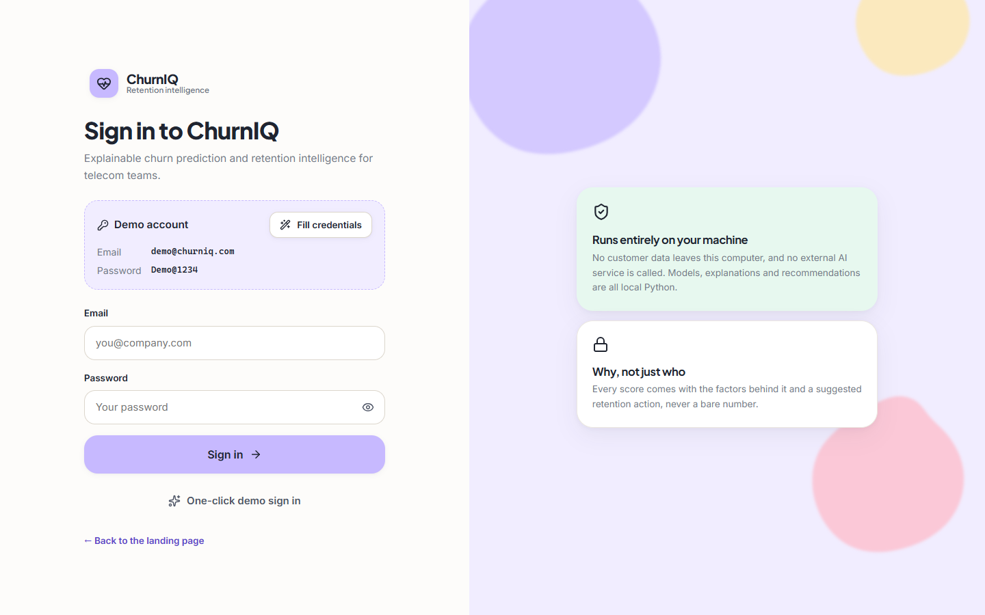
Figure 38: Sign-in page with the one-click demo account
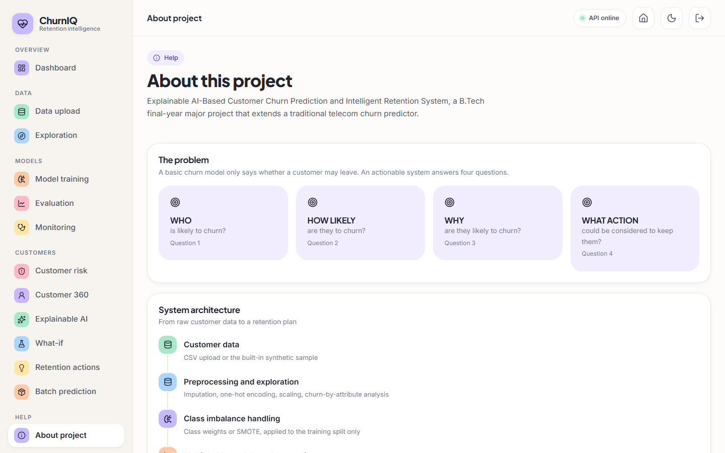
Figure 39: About page
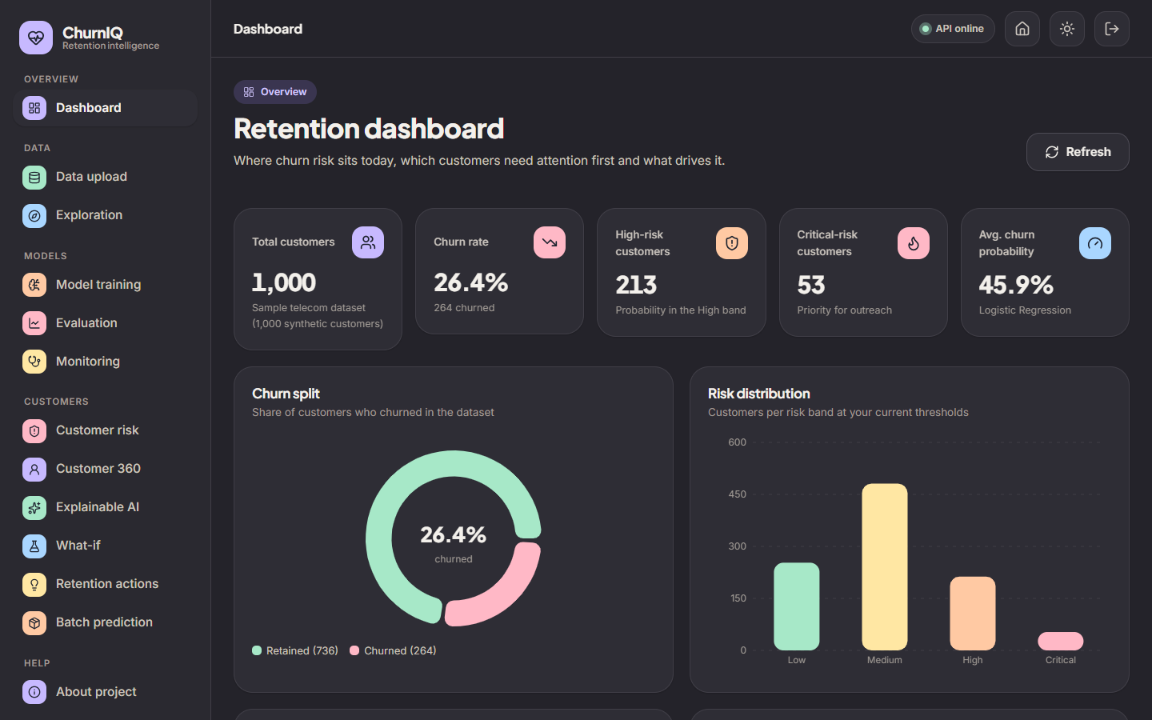
Figure 40: Dashboard in the dark theme
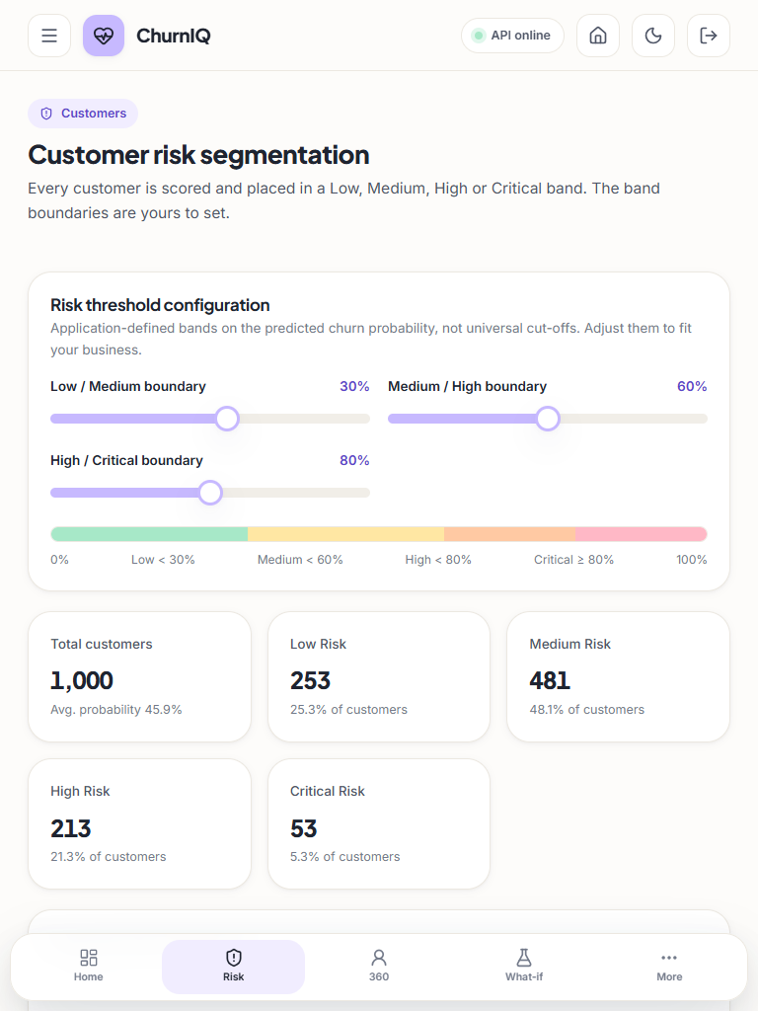
Figure 41: Customer risk page at tablet width (768 px)
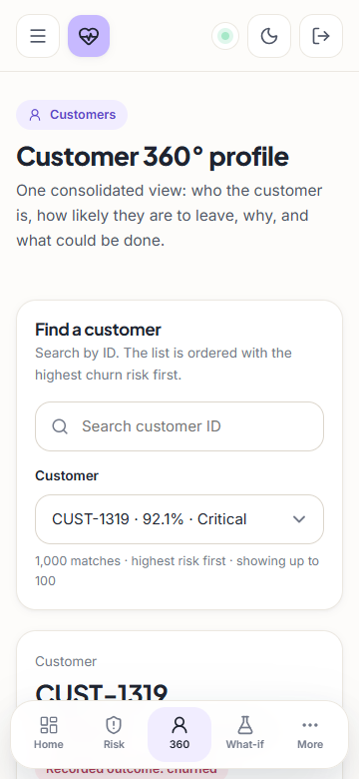
Figure 42: Customer 360 at phone width (360 px)
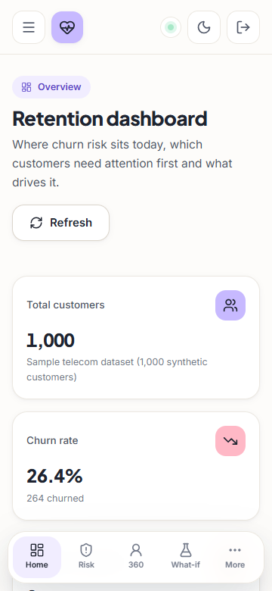
Figure 43: Dashboard at phone width (360 px)

